Final Report

Designing a specification, interpreter and graphical interface for a visual programming language.

Knight, Charles H E

1805098

Acknowledgements

I would not have been able to complete this project without the help of my primary supervisor, Prof. Michael Sanderson, and my secondary supervisor, Amorim Renato. They were the ones who first raised the concept of a potential scope reduction, and have helped me keep my goals in mind throughout my project.

Alongside all of other the authors I have cited throughout this report and others, I would also like to give special consideration towards Andrew W. Appel, for it was his literature that contributed greatly to my understanding of the subjects that would ultimately be of great value whilst completing this project. Without his book “Modern Compiler Implementation in Java”, I would have found it far more difficult to grasp the intricacies required to implement my interpreter.

I would like to also give thanks to my friends and family, for their emotional support and guidance throughout the year and my university life in general.

Project Abstract

Programming code with a text-based IDE can be a challenge for new developers. Depending on the responsiveness of the IDE, spelling and grammatical mistakes can be ignored until execution, at which point it can become incredibly cumbersome to root out every small mistake made.

My project aimed to create a specification for a programming language that would integrate with an interpreter, which could be used to analyse and execute code. The interpreter incorporates a lexical analyser to tokenise text, a parser to define the text, a tree constructor to order the definitions, and an evaluator with symbol tables to store variables. Code files can also be imported using a text-based terminal.

The graphical interface allows for the manipulation of graphical blocks that can be slotted together to produce chains of blocks that can be analysed by the back-end interpreter. The intuitive lock-and-key shapes allow for easy understanding of how blocks interact.

This project was developed with help from the book 'Modern Compiler Implementation in Java' by Andrew W. Appel. Each of the backend analysis stages was created with pure Java, without the aid of language recognisers such as SableCC or ANTLR. The GUI was created with a combination of Swing and JavaFX.

Table of Contents

Symbols and Definitions 2

Project Background 5

Compilation and Interpretation 5

The Nature of An Interpreter 5

Analysis Stages 5

Symbol Tables 5

Parser Generators 6

Visual Programming Languages 7

Scratch 7

Scratch’s Use of Shape and Colour 7

Project Implementation 9

Lexical Analysis 10

Lexical Tokens and Enumerations 10

Construction of the Regex Tree 10

Turning the Regular Expressions into NFA’s 11

Turning the NFA’s into DFA’s 12

String Input Validation 12

Syntax Parsing 13

Language and Grammar Rules 13

The Parsing Table and its Actions 13

Constructing the DFA and Parsing Table 14

The Parsing Algorithm 14

The Error Corrector 15

Syntax Tree Construction 16

Creating the Concrete Syntax Tree 16

Object Factories 17

Factory Methods and the Abstract Syntax Tree 17

Semantic Actions 18

Visitor Patterns 18

Symbol Tables 18

Graphical User Interface 20

The Graphical Frame 20

The Shape of Token Blocks 20

User Interaction with Token Blocks 21

Block Text Analysis 22

Block Parsing 23

Project Design and Structure 24

Folder Structure 24

Class Structure 26

Testing 29

Test-Focused Design 29

Unit Testing 29

Integration Testing 30

Full-scale Testing 30

Terminal Output 30

Printing Objects 30

Parsing Table Construction 31

Code Parsing 32

Project Planning 33

Jira Documentation 33

Project change and adaptation 34

Risk Management 35

The January Scope Change 35

The Easter Break 35

Conclusion 37

Citations 39

# Symbols and Definitions

|  |  |  |
| --- | --- | --- |
| PHRASE | DEFINITION | SYNONYMS |
| Abstract Syntax Tree | A tree structure that holds *concise token* nodes to present semantic information in a lean way. | AST |
| Analyser | A program that recognises a particular language and performs a particular function based on that. |  |
| Block Chain | A series of *token blocks* strung together through their slots. | Chain |
| Block Slot | A slot on a *token block* that other blocks can fit onto to form syntactical structures with it. | Slot |
| Compiler | An analyser that translates code in its source language to another target language. |  |
| Concise Token | A node of an *AST* that represents an entire concept of a *language* rather than a single *text symbol*. |  |
| Concrete Syntax Tree | A tree structure that holds *context token* nodes to present syntactic information, including extraneous grammar *tokens* such as brackets and commas. | CST  Parsing Tree |
| Context Token | A *token* that contains additional information, including its text string, and its line and column numbers in the full text. Can hold child tokens to form a concrete tree structure. |  |
| Derivation | An ordered series of reductions. |  |
| Deterministic Finite Automaton | An automaton that has no free nodes. | DFA |
| Eating | The process by which an automaton analyses symbols of input and determines whether they match with any edges leading from the current state. |  |
| Interpreter | An analyser that executes specific actions based on the specific constructions contained within code it has been given. |  |
| Lexical Analysis | A process that takes a piece of text and tokenises it, creating a list of discrete *tokens* that contain the convey the structure of the text. | Lexing |
| LR Parsing | A type of *parsing* that creates *derivations* bottom-up, after it has seen all of the *tokens* required to *reduce*. It is deterministic, not needing to guess potential input. |  |
| Non-Deterministic Finite Automata | An automaton with free edges that do not need to *eat* any input to be traversed. | NFA |
| Non-Terminal Token | A *token* in a *CFG* that has at least one *production rule* assigned to it. |  |
| Parsing | A process that takes a tokenised block of text and determines both its meaning, and whether it is a valid lingual construct. | Syntax parsing  LR parsing* |
| Parsing Table | A table used in *parsing* that holds all of the possible actions that the parser could take, based on its current *state* and the input it is given. | LR parsing table* |
| Pointed Production Rule | A production rule that has a pointer to describe the parser’s current progress through it. | Pointed grammar rule |
| Production Rule | A single definition in a language’s *syntax*. Contains the definition name and its description in the form of a series of *tokens*. | Grammar rule |
| Reduction | A simplification of a number of tokens in a grammar rule into the single token that describes them. |  |
| Regex Block | A node in a tree that is used to create regular expressions. |  |
| Regular Expression | A string-based code that is used in validation of other strings, determining whether a text string has the correct order of characters or not. | Regex |
| Semantic Action | Distinct behavioural actions that are assigned to a *concise token* to allow them to execute behavior. |  |
| Source Language | The language that an analyser recognises. | Language* |
| State | A single node of an automaton. Extends edges that lead to other states in its automaton. |  |
| State Automaton | A graph structure with nodes and edges that can be traversed by continually *eating* its input to traverse it. | Automaton |
| Symbol | A single unit of input that is fed into a state automaton. |  |
| Symbol Table | A table that holds the values of all of the variables that are in the current *scope*. | Hash-based symbol table |
| Syntax | The set of rules that determine how a language’s phrases and statements are structured. | Grammar |
| Terminal Token | A *token* in a *CFG* that doesn’t have any *grammar rule* assigned to it. |  |
| Token | A single discrete unit that represents a specific *text symbol*. For example, “==” could be represented by an EQUALS token. |  |
| Token Block | A distinct interactable shape in the graphical user interface that represents a token in the *interpreter*’s language. |  |
| Virtual Block | A *token block* that is invisible to the user, representing an abstract *concise token* class. |  |
| Visual Programming Language | A programming language that relies on a visual interface to program code. | VPE |

*For the particular context of this report, and unless stated otherwise.

|  |  |
| --- | --- |
| SYMBOL | MEANING |
| $$D→S_{1} S_{2}…S_{n}$$ | A *production rule* with name $D$, and definition *tokens* through $S_{1} S_{2}…S_{n}$. |
| $$D→S_{1} . S_{2}…S_{n}$$ | A pointed production rule. The dot states the location of the rule’s pointer. |
| $$\{n\}$$ | A *state $n$* in its *automaton*. |
| $n$** | A starting *state $n$* . This is the opening state of its *automaton*. |
| < $n$ > | An ending *state $n$*. Traversing to this state with no valid input ends its *automaton* with a success. |
| $\{n\}$ $→$ $\{m\}$ | A *state* transition from $n$** to $m$**. |
| $\{n\}$ $-s→$ $\{m\}$ | A *state* transition from $n$** to $m$**, eating input *symbol $s$* . |
| % | A modulus operation. |

# Project Background

## Compilation and Interpretation

### The Nature of An Interpreter

An *interpreter* is a program that is used to determine the structure and meaning of a piece of text-based code, and then execute instructions based on the information contained within that code. This is distinct but related to a compiler, in that they are both programs which *analyse* source code in a particular language and carry out specific actions based on its meaning, however a compiler directly translates from the source language to another instead of executing any actions visible to the user.

### Analysis Stages

Both interpreters and compilers run through a series of stages to analyse a piece of code, within which compilers create a series of “intermediate representations of the program being compiled” [5], as do interpreters. However, interpreters usually end after the semantic action execution, as they do not need to carry on to the further “synthesis” [6] steps of the compiler – these are mainly focused on further analysis and data structure reorganisation for heightened efficiency.

* *Lexical analysis* is the process by which a source code input string is “[broken] … into individual words or ‘*tokens’*” [6]. This allows the analyser to understand its structure, and manipulate its individual pieces to a far more flexible degree than if it was using comparatively obtuse text.
* *Syntax parsing* is paired with lexical analysis, and takes the lexically analysed tokens and attempts to determine the “phrase structure” [6] of the code. This involves attempting to figure out if the sentences it has been given can form a grammatically correct construct in the its *language*. In the process of parsing, a parser forms a *parsing tree* that structures all of the reductions it has made.
* After the analyser has determined that the tokens form a *syntactically* correct construct, it will attempt to trim down the created parsing tree, removing extraneous tokens to ensure that the tree is concise and navigable as possible. This new tree is called an *abstract syntax tree*.
* To execute instructions based on its code, the analyser utilises a series of *semantic actions*. These actions are performed after the *abstract syntax tree* has been created. They are each tied to a specific concise token class within the tree, and allow each token to perform specific behaviours. When executing the instructions it has created from analysing the source code, an analyser will traverse its AST, running each semantic action in order.

Because compilers reduce a high-level language to a low-level one, they are usually slow upon first compilation, but quick to execute on code they have already compiled. Interpreters on the other hand are slow to execute code, as they have to run all of their systems at once, however there is no extra distinct execution step after the processing is complete.

### Symbol Tables

Symbol tables are the main way that an interpreter’s variables are stored [9], and can work in concert with semantic actions to allow analysed code to utilise variable assignment and reference. A common way to implement symbol tables is to use a hash-based approach. Hash-based symbol tables can work by storing linked-lists of variable bindings together, and storing the lists in an array using the hash of the identifier they are stored under [10][11].

Because my language did not use static declaration, I did not use my symbol tables to store type information, instead using it to hold stored values for later reference. This is in contrast to the purpose of the symbol tables shown in [7].

### Parser Generators

A parser generator is a program that allows a user to define lexical tokens and syntax to generate a parser. Examples include ANTLR, YACC, and Ohm [8]. Generally, parser generators allow the creation of regular expressions to validate token strings, and the implementation of context-free grammars to specify the reductions that the parser should make.

My program could be considered a parser generator, as it does create parsers based on rules given to it, which are specified in code.

## Visual Programming Languages

A visual programming language is a programming language that utilises graphical structures rather than text-based input as its interface to the user. Many examples of visual programming languages exist, including Scratch and Kodu.

### Scratch

Scratch is “a visual programming environment that lets users create interactive, media-rich projects” [1] that utilises building blocks to allow users to easily build scripts. My program is similar to this in principle, allowing users to slot blocks together to create chains that can be analysed.

One big distinction between Scratch and my own program is the differences in how code is executed in the backend. “A key feature of Scratch is that it is always live … There is no compilation step or edit/run mode distinction” [2]. By contrast, my program does have a compilation step, and its graphical user interface is heavily integrated with its backend interpretation functionality. Every time an editable block has its text changed, the lexical analyser immediately determines the new meaning. Every time blocks are slotted together, their meaning is analysed by the parser and if the program finds an issue, the slot that caused it flashes red.

Scratch does have feedback functionality [3], but handles it in a way that does not involve a compilation step. Because my visual interface integrates with the interpreter to provide feedback, it does suffer slight lag while processing, but this is mitigated by the fact that the block’s interpreter is contained within a separate thread to the interface.

### Scratch’s Use of Shape and Colour

Scratch uses different shapes to communicate how its blocks are meant to fit together. Different blocks have notches and shaped slots [4] to inform the user which blocks they can connect with.

Utilising this concept, my interface also utilises shaped slots to indicate which blocks can interact and connect with as well, as can be seen in the table on the next page.

|  |  |  |
| --- | --- | --- |
| BLOCK TYPE | BLOCKS | SHAPE |
| Expression Symbol | Assignment Block  Index Block  Operator Blocks (+, –, etc.)  Equation Blocks (<, >, etc.) |  |
| Value | Value Blocks (null, identifier, integer, etc.) |  |
| Header Block | If Header  For Header  Method Definition Header |  |

This use of shape allows for intuitive understanding of the interaction between blocks, without having to understand the intricacies of how each object behaves under the hood.

However, it may not necessarily be entirely clear how certain slots connect, however. As such, the blocks also produce a green glow effect that emanates out of their slots, which gets brighter if they can interact with a matching slot in their vicinity. This can be seen in figure 1 to the left.

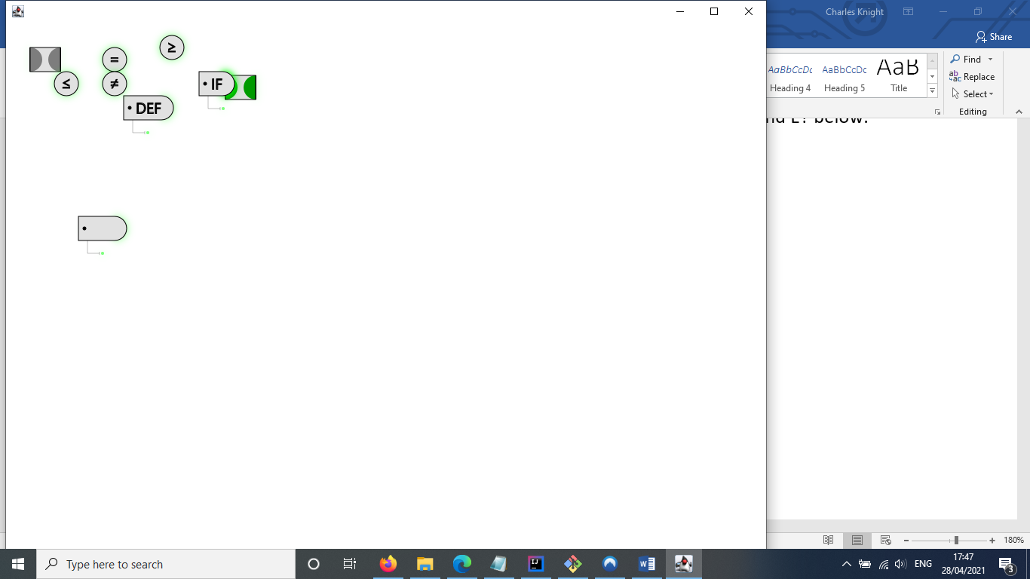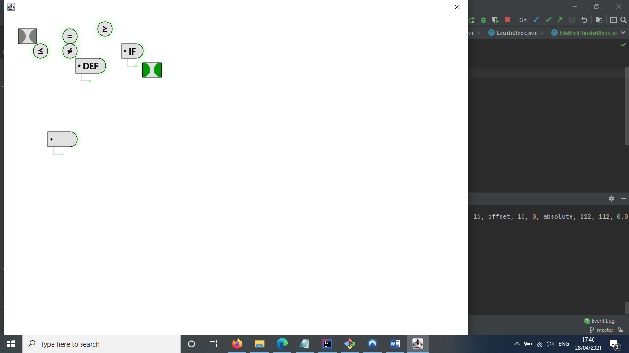

⌂ Figure 1

Scratch also uses colour to indicate block relationships. Each block type is colour-coded to inform the user of what category it fits under [4]. However, unlike Scratch, all of the token blocks in my program are grey.

# Project Implementation

As stated in the section on project structure, my project’s program implements four of the stages of compiler execution to determine the meaning of the code input to it. These stages are lexical analysis, syntax parsing, abstract syntax tree construction and semantic action execution. It also includes a graphical interface for the visual language, which utilizes interactive building blocks to function.

A large part of these stages is transferring data from a less usable data structure to one that is more usable without eliminating the information contained within. As such, these stages utilise many different types of data structure, from different types of state automaton to trees and hash-tables.

These large-scale features utilise many smaller structures in order to allow them to function, including enumeration constructors, visitor patterns, object factories and factory methods. These mechanisms will be explored in this section, as they arise in discussion of the program’s larger-scale systems.

## Lexical Analysis

The *lexical analyser* consists of a class called ‘Lexer’. The Lexer creates trees that represent the regular expressions given to it in an informative way, assigning them to tokens. It then uses these trees to create NFA’s, and then uses these NFA’s to create DFA’s. These DFA’s are then used to match slices of input string with their corresponding token, resulting in a fully tokenized input that can then be sent to the program’s parser.

### Lexical Tokens and Enumerations

To catalogue its array of tokens, Lexer stores an enumeration called ‘type’. Each element of the enumeration refers to a single token, and its constructor takes the class objects of its relevant AST token and its graphical token block. This can be seen in figure 2.

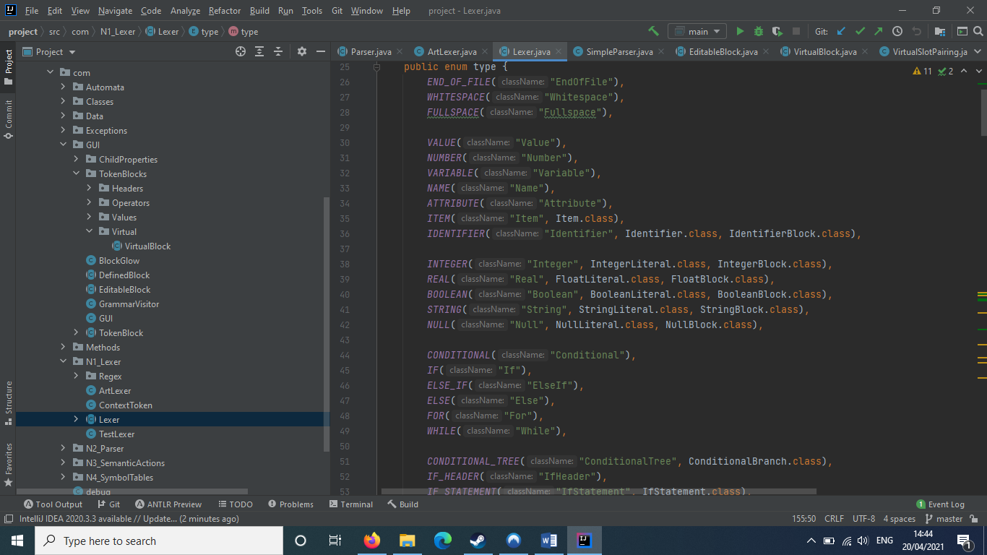

⌂ Figure 2

Each type element can be refered to using its actual element index, or using its string name. For example, END_OF_FILE can also be referred to as “EndOfFile”.

The type enumeration is used in many different systems throughout the project, including lexical analysis, syntax parsing and the graphical interface.

A type element contains an object factory (see *Object Factories* in *Syntax Tree Construction*) for both its relevant token and its graphical block. These are created using a generic of the class objects passed through the element’s constructors, as can be seen in figure 3.

⌂ Figure 3

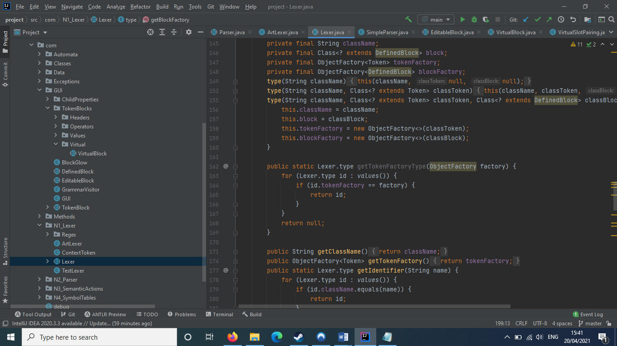

### Construction of the Regex Tree

To create a regular expression (Regex) tree from a regex string, the Lexer must determine first how each of the expression’s nesting is structured, and then what each of the individual phrases mean.

To determine nesting, the Lexer creates an object of a class called ‘RegexBase’. This RegexBase object creates a list of RegexAttribute objects to represent the expression’s phrases enclosed in brackets. These can either be closed (closing bracket found) or open (still waiting for a closing bracket). When an open bracket is found, the RegexBase creates a new RegexAttribute, setting it at open at the bracket’s location and making it a child of the current open Attribute. When a closing bracket is found, the last open RegexAttribute is closed at the closing bracket’s location, and the entire string slice from the Attribute’s opening and closing are placed into it. This simulates phrase nesting.

After the expression’s nesting is determined, the RegexAttributes are parsed. In the string slice of a parent Attribute, each of its children have their string slices replaced with $\{n\}$ (this is not an automaton state), where $n$ is the child’s index.

For example, “ $\left[a-z\right]*(0-9)$” would be turned into “ $\left\{0\right\}*\{1\}$”.

When the Attribute’s parser encounters these codes, obtains the result of the relevant child’s parsing. For any other symbol, it will create the relevant RegexBlock object:

|  |  |  |
| --- | --- | --- |
| SYMBOL | CREATED OBJECT | PARAMETERS |
| | | RegexAlternation | Child or character symbol to either side of the ‘|’. |
| * | RegexRepetition | Child or character symbol just before the ‘*’. |
| – | RegexSymbolRange | Child or character symbol to either side of the ‘–’. |

These RegexBlock objects are assigned as children of new RegexIndex objects that hold them. These Index objects are constructed into a full Regex tree at the end of the parsing.

### Turning the Regular Expressions into NFA’s

When transforming a regular expression to an NFA, the Lexer runs through a recursive function that analyses each node of the Regex tree.

As can be seen in figure 4, populate() checks if the regex block is any of an alternation, concatenation, repetition or a symbol.

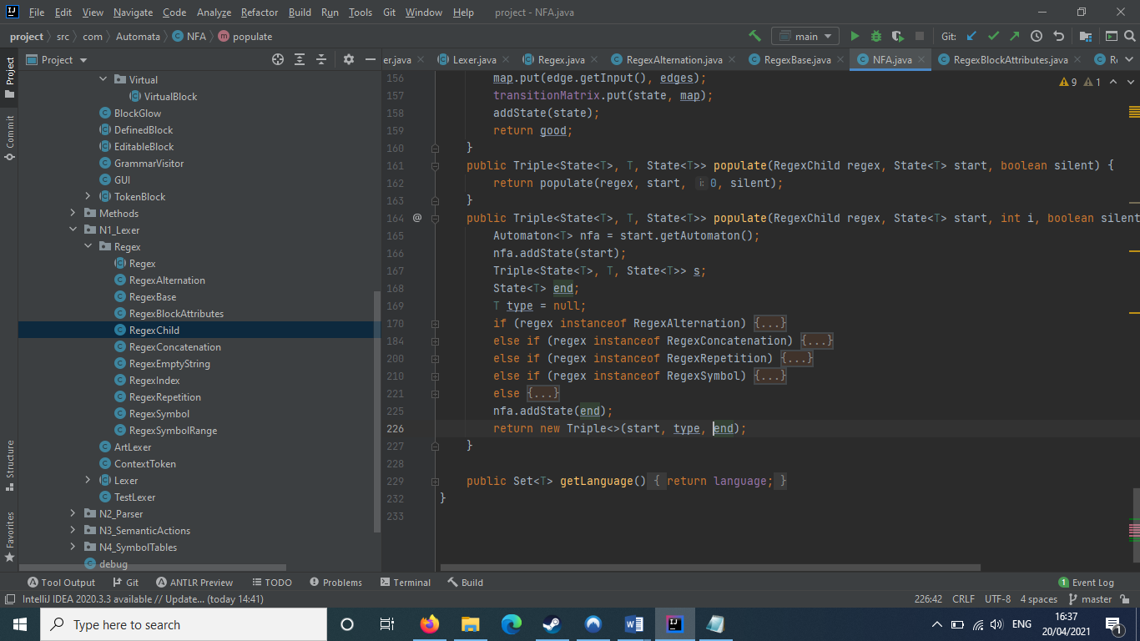

⌂ Figure 4

For each of the block types that populate() checks for, it will create a different smaller automaton that is appended to the larger one.

The way populate() works could be viewed as a larger automaton creating smaller automata in a tree-like structure of nodes – figure 5 gives an illustration of this point.

⌂ Figure 5

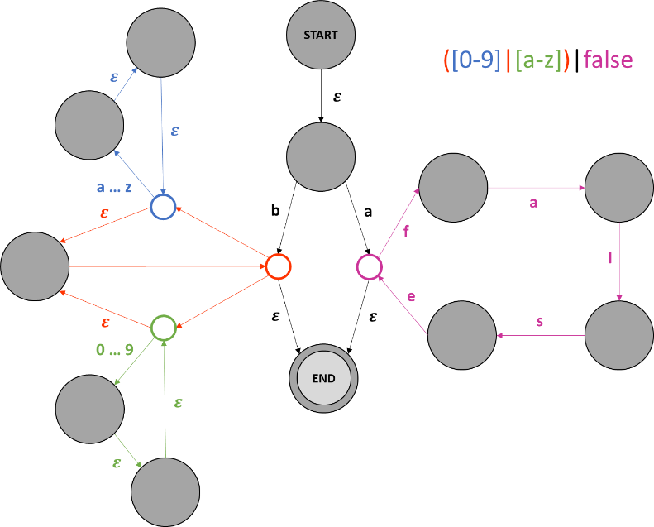

### Turning the NFA’s into DFA’s

To create a DFA from an NFA, the $ε$ transitions need to be eliminated to simplify the automaton. To do this, the NFA creates sets of states which could each form a singular state without eliminating any route between any of its important states.

This is done by determining closure. For any state $n$, its closure is “the set of states that can be reached … without consuming any of the lexer’s input” [12]. Closures that intersect completely are collapsed into a single state. An example of closure can be seen in figure 6.

⌂ Figure 6

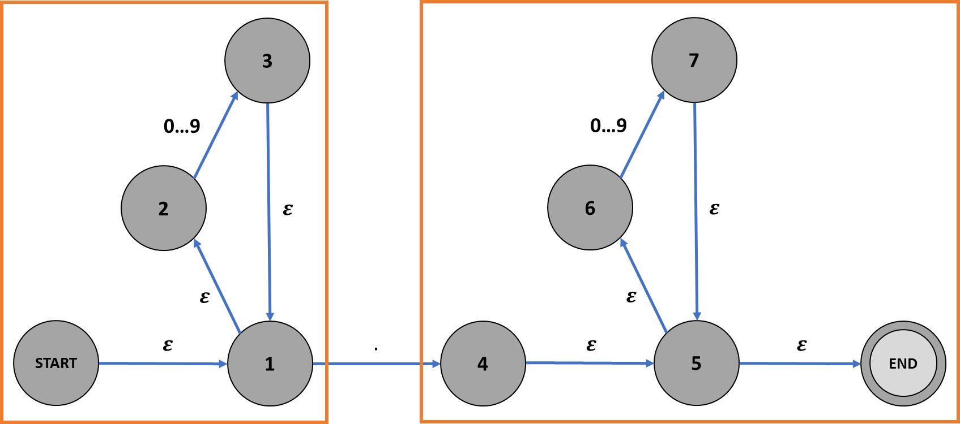

⌂ Figure 7

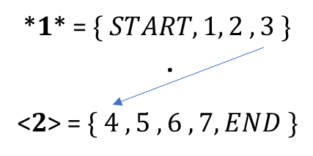

These state sets form the states of the new DFA. Transitions are formed between them using any costly (non- $ε$) transitions between any of their states. Figure 7 gives an example of this done to the NFA given in figure 6.

### String Input Validation

To validate an input string, the Lexer runs it character by character through its set of DFA’s. If one of its DFA’s successfully terminates, the entire string of characters that was run through that automaton is recorded as the context string for a new *context token*, which is placed in a list. The Lexer then restarts the loop, running the next characters through its set until it no longer has any characters to analyse.

The list of context tokens are then output as the result of the analysis.

## Syntax Parsing

After the string expression has been lexically analysed, the tokens are sent through a parser to determine their meaning. For my project, I decided to utilise an LR parser rather than a predictive parser, because of the fact that an LR parser is far more automated and powerful, being able to concretely determine the correct grammar rule to utilise rather than simply making a guess before the tokens have been seen. Additionally, an LR parser can be constructed in an automated way, utilizing DFA’s which I had already implemented earlier on in the project to create the lexical analyser.

### Language and Grammar Rules

The parser utilises a system of context-free grammar to determine the syntax of its tokenised code. A grammar rule is instantiated using the addRule() method, as can be seen below.

|  |  |
| --- | --- |
| RULE | METHOD CALL |
| $$Phrase→Phrase EndOfFile$$ |  |

As can likely be inferred from above, many tokens in the parser’s language utilise aliases to make grammar rules more readable. These aliases are held in a hash map, and can be used to replace any string-based token name in any of the parser’s methods.

⌂ Figure 8

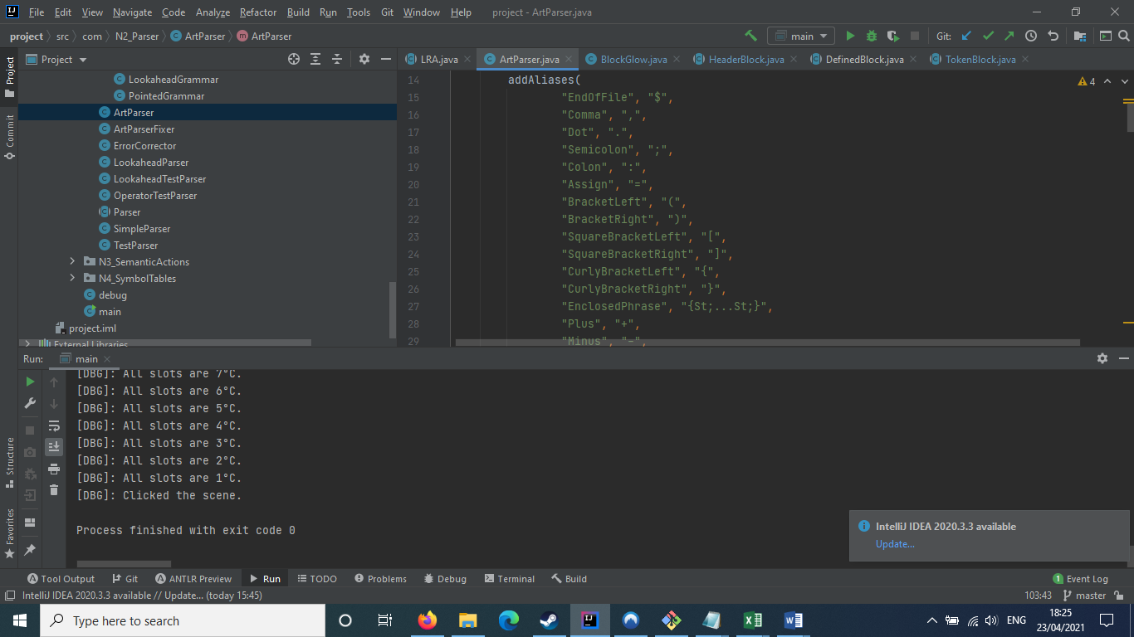

As can be seen in figure 8, most terminal token aliases are single characters, as they represent a single concept. However, non-terminal token aliases are more complex symbols – these types of aliases generally are not utilized in grammar declarations, and are instead used to make the parsing table’s columns more readable (see the next section).

### The Parsing Table and its Actions

To parse through a tokenised expression, the interpreter must use a *parsing table*. Each of the column headers of a parsing table consist of all of the possible tokens in its *language*, and the row headers of the table consist of each of its DFA’s states.

Any cell C(symbol, state) in the parsing table contains a list of parsing actions that could potentially be performed on either the parser’s input or stack. This program uses six actions, as listed below.

|  |  |  |
| --- | --- | --- |
| ACTION | CODE | PURPOSE |
| ShiftAction | s $n$ | Used for *terminal tokens*. Attempts to transfer its column’s symbol from the input to the stack. If this is successful, transitions from the current row of the parsing table to row $\{n\}$. |
| GotoAction | g $n$ | Used for *non-terminal tokens*. Otherwise, the same as s $n$. |
| ReduceAction | r $n$ | Finds grammar rule $n$, and if the stack’s most recent $L$ context tokens are equal to $n$’s definition, attempts to replace those $L$ tokens with a new context token $c$ of type $D$. Assigns the replaced symbols as $D$’s children. |
| LookaheadAction | r $n$ if $s$ | Similar to r $n$, but will only reduce if the input’s closest token is of type $s$. |
| NoLookaheadAction | r $n$ ifnot $s$ | Similar to r $n$, but will only reduce if the input’s closest token is not of type $s$. |
|  |  |  |

### Constructing the DFA and Parsing Table

As stated in the introduction to this section, an LR parser constructs and utilises a DFA to inform its parsing behavior. Unlike the lexer, this particular DFA utilises tokens for its language, and it also utilises states that contain sets of grammars, which simulate the progression of the parser through its various production rules.

As implied by the name, these pointed grammars contain a pointer, with its position determining how far the parser has shifted itself through its production rule.

For example, $IfHeader→If \left( . Equation \right)$ shows that the parser has shifted $If$ and $($ tokens from the input to the stack.

A state that contains a grammar that has shifted through all of its tokens creates a reduce action in its row of the parsing table for that particular grammar. Otherwise, it creates a shift or goto action that follows the token’s transition edge to a new state.

### The Parsing Algorithm

To parse the tokenised code, the parser utilises its parsing table, an input list and a token stack. It starts at the row for $\{1\}$, and at each stage of parsing, it loops around, attempting to navigate around the parsing table using the actions it finds using the top token in its stack. An example of this is shown in figure 9 below.

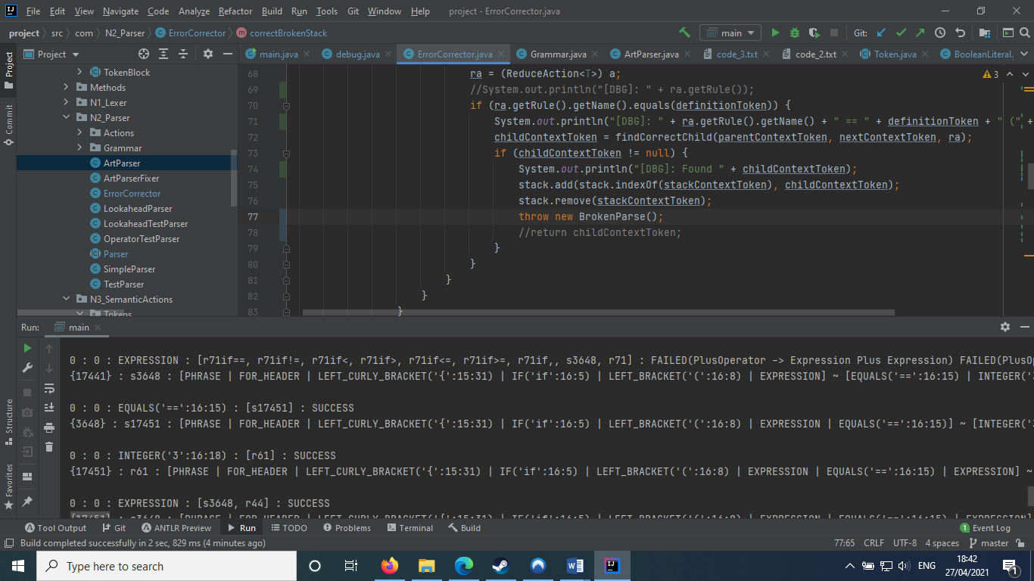

⌂ Figure 9

When attempting to utilise the actions in a cell, the parser attempts to run through each of the cell’s actions until it finds one that successfully executes, as can be seen in figure 10. As such, actions near the front of a cell have priority over ones towards the back.

⌂ Figure 10

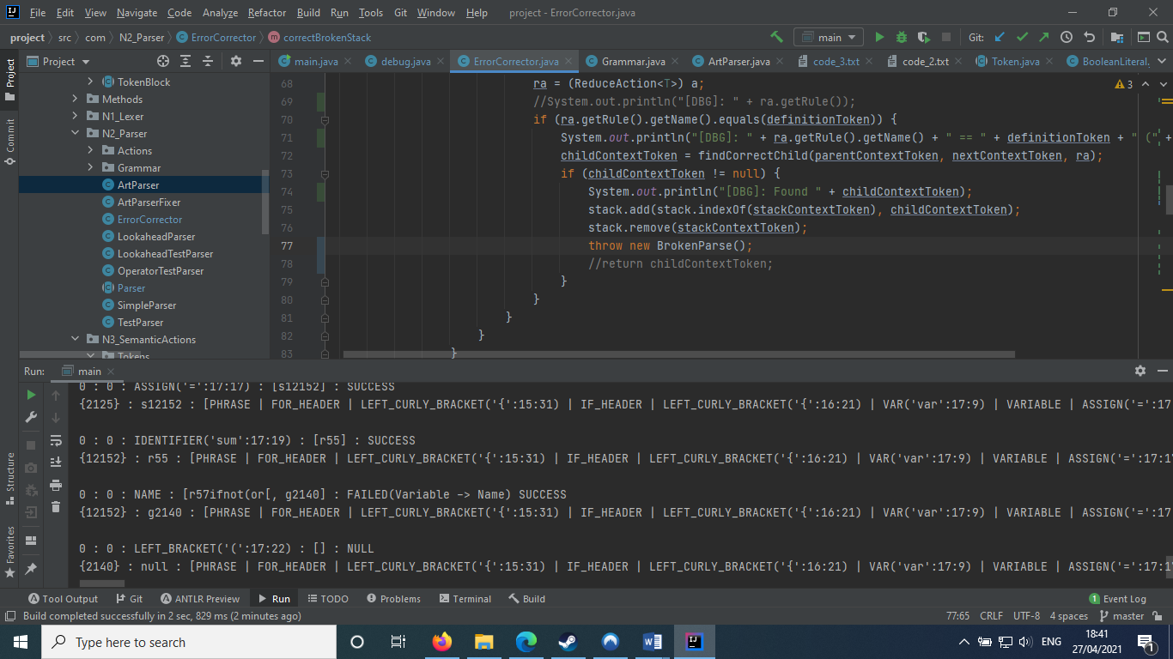

If the parser finds that the current state has run out of possible actions for it to perform, it will reset its state back to $\{1\}$, effectively restarting itself as shown in figure 11. If even $\left\{1\right\}$ does not have any potential route for it to restart traversal, the parser’s error corrector will activate, as described on the next page.

⌂ Figure 11

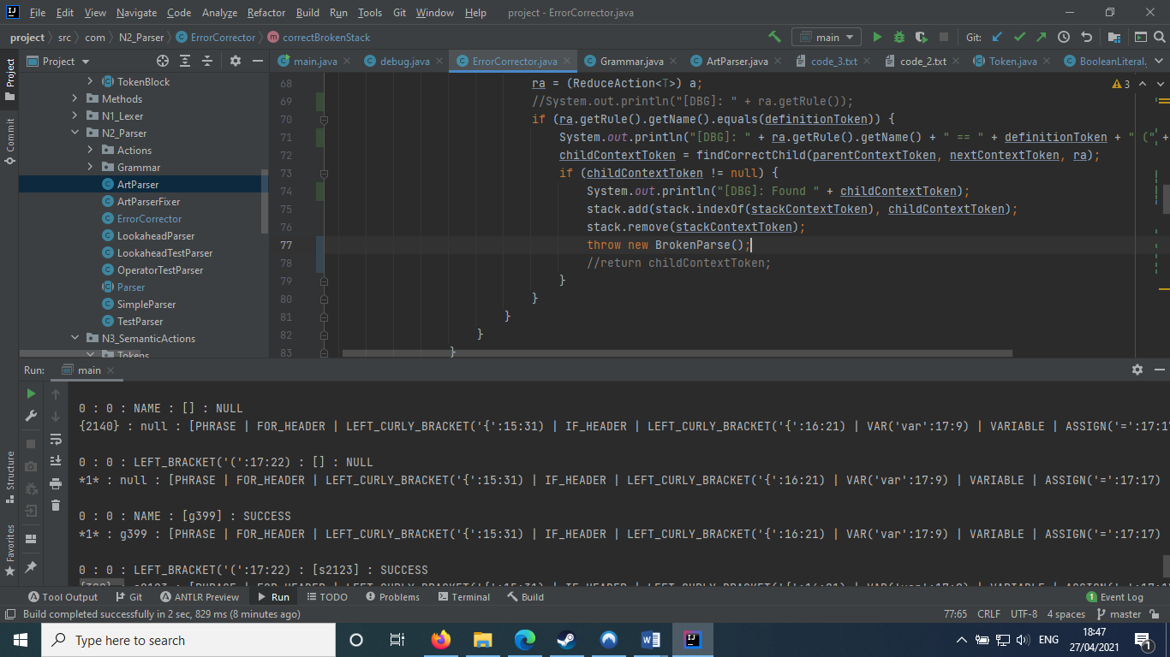

### The Error Corrector

If the parser cannot find any available action to perform on the current input and stack, it will not break immediately. Instead, it will attempt to alter the stack to allow it to continue to perform actions, ensuring that it will be able to continue on from the point where the stack was inviable.

It does this using its error corrector, which is located in a separate class from the main parser implementation. The error corrector works by attempting to find the most similar rule to the last few tokens in the stack. This is done to ensure that the fewest possible tokens are replaced.

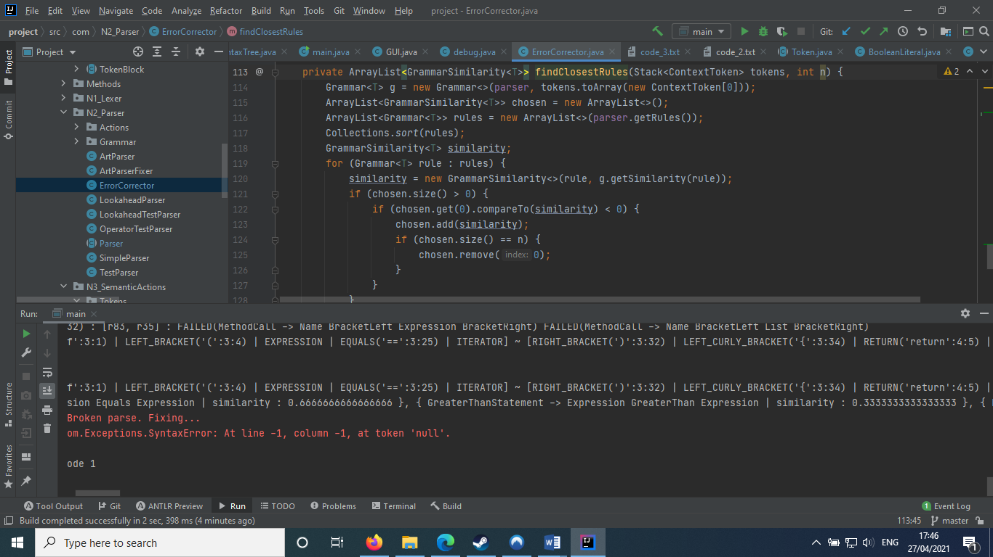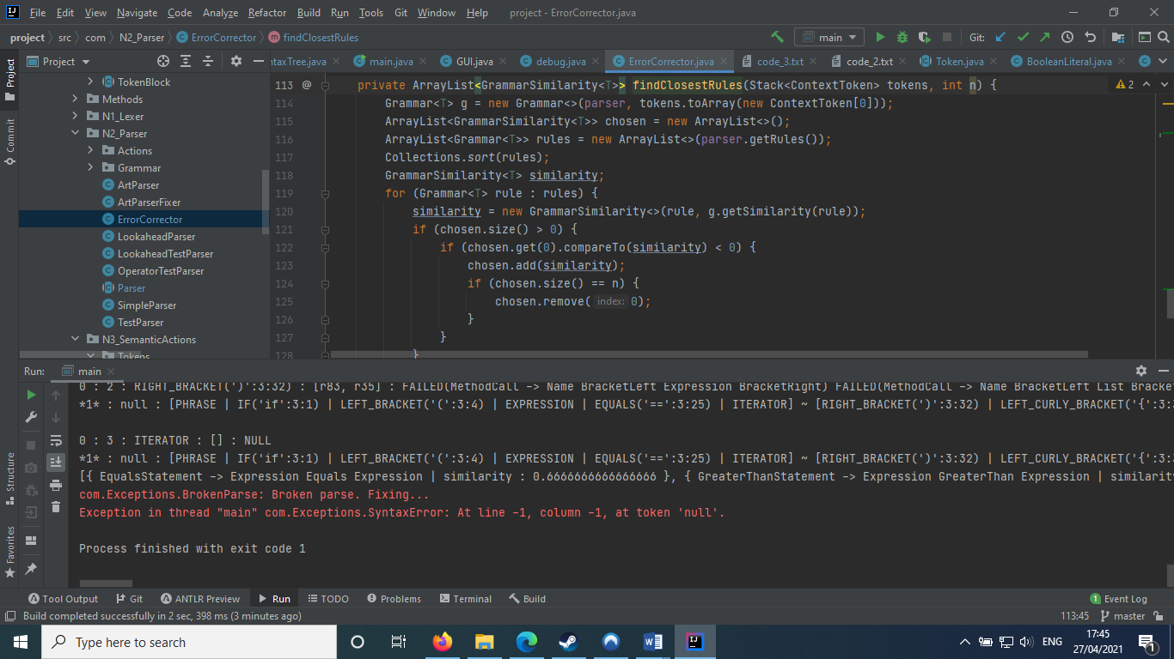

When calculating the similarity, the tokens are turned into a Grammar<>. This is done because similarity can only be compared using the Grammar class’ getSimilarity() method. Similarity begins at 0, then accumulates based on whether the tokens at each position are the same or not.

The rate of accumulation is based on the length of the two grammars, as shown below. $A$ is accumulation rate, $L_{1}$ is the length of grammar 1, and $L_{2}$ is the length of grammar 2.

$$A=\frac{1}{max(L_{1},L_{2})}$$

As such, comparing two three-length grammars would cause an accumulation rate of 33%, whereas a three- and a five-length grammar would cause accumulation to equal 20%. This is to ensure that accumulation does not increase too quickly for the final few tokens to be counted in the final score. The corrector will move through all of the tokens in both grammars, meaning that if the grammars are not equal in length, an Exception will occur for every token of difference. This Exception causes $A$ to be deducted from the similarity score to punish grammars that are not equal in length -- $Array→[ List ]$ and $Item→Name [ Expression ]$ are not the entirely similar grammars, despite being alike at first glance.

Similarity also rewards streaks, instances where tokens are matched consecutively. This is done to identify grammars that share the same constructs, and to more precisely identify the potential meaning of the broken tokens. For example, $List→List , List$ and $List→List , Expression$ would be considered more similar than $Minus→Expression-Expression$ and $List→Expression , Expression$.

Once it has found the most similar rule, it runs back through the list of states it had already parsed through to find which reduction rule could be used to create a new token to replace the erroneous one, and utilises it to create a new derivation that replaces the old one.

The error corrector provides a failsafe, reducing the likelihood that the parser completely fails.

## Syntax Tree Construction

### Creating the Concrete Syntax Tree

To create the concrete syntax tree, the parser ensures that every reduction made in its parsing is stored. This can be seen in figure 12.

When the tree is created, each of these reductions are used to create a derivation, which acts as a parent/child node in the syntax tree, as can be seen below.

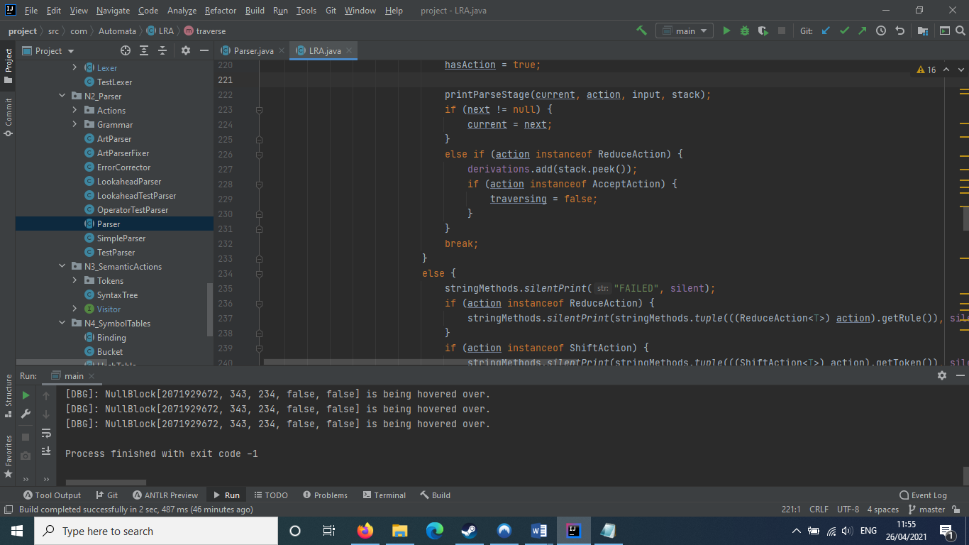

⌂ Figure 12

$IfHeader→If \left( . Equation \right)$ creates the derivation

The constructor algorithm holds a list of ‘tips’, token nodes which don’t have any parents. When it runs through each reduction’s definition tokens, it attempts to determine if they match any of the tips it has found. This ensures that derivations connect to each other as well, as parents and children.

⌂ Figure 13

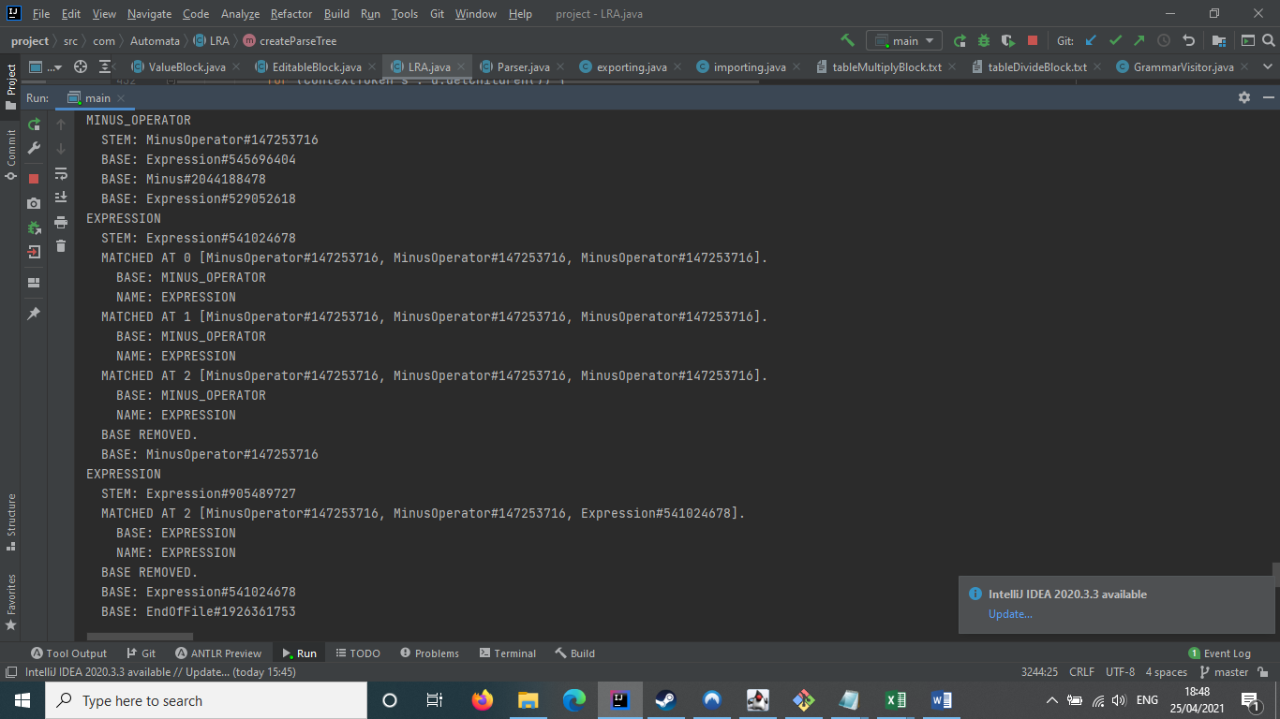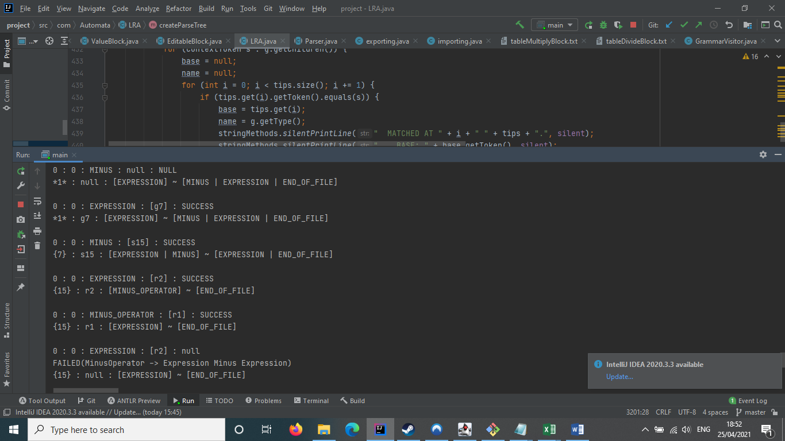

⌂ Figure 14

Figure 13 shows the construction of a CST for the parsing shown in figure 14. As can be seen, the construction algorithm started from the top downwards. It created the tree seen in figure 15, below.

⌂ Figure 15

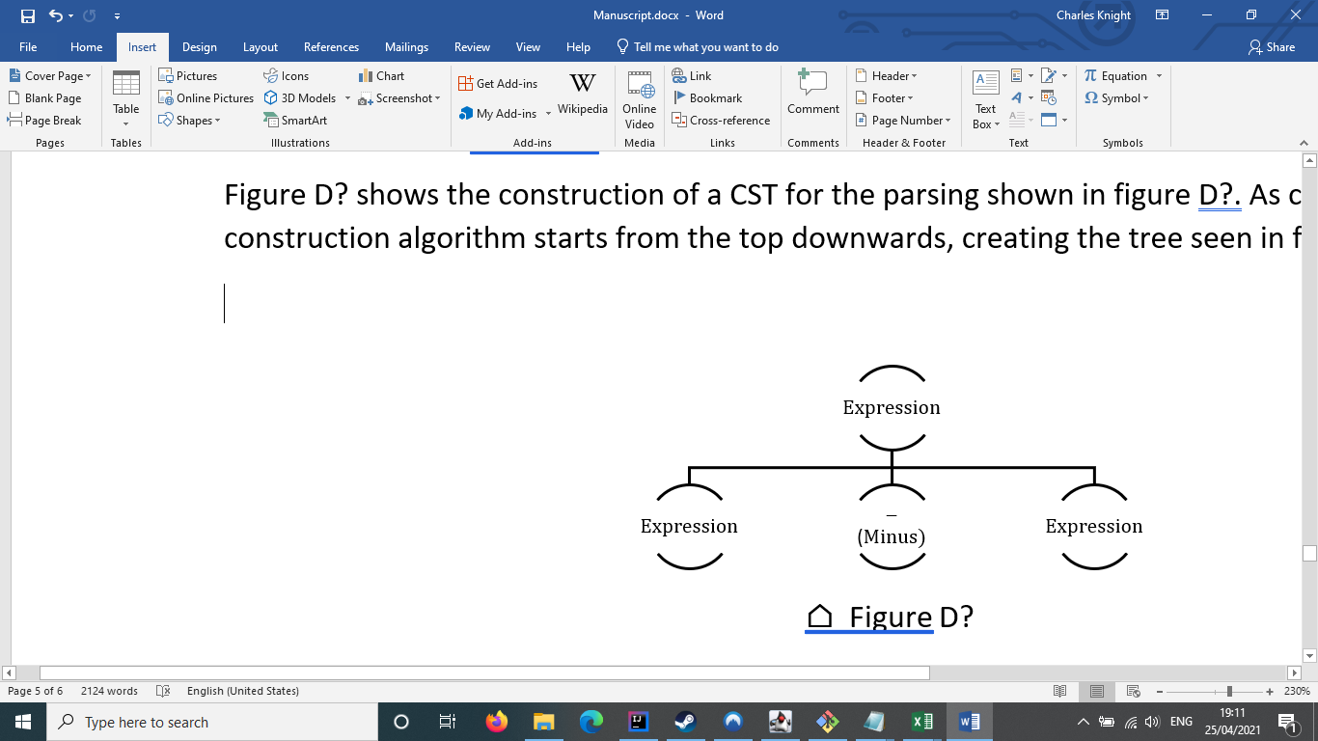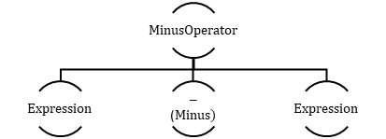

### Object Factories

My program utilises factory patterns quite extensively to create a wide variety of objects. Specifically, one particular generic class, ObjectFactory<>, was used to create all of the empty objects in the program.

⌂ Figure 16

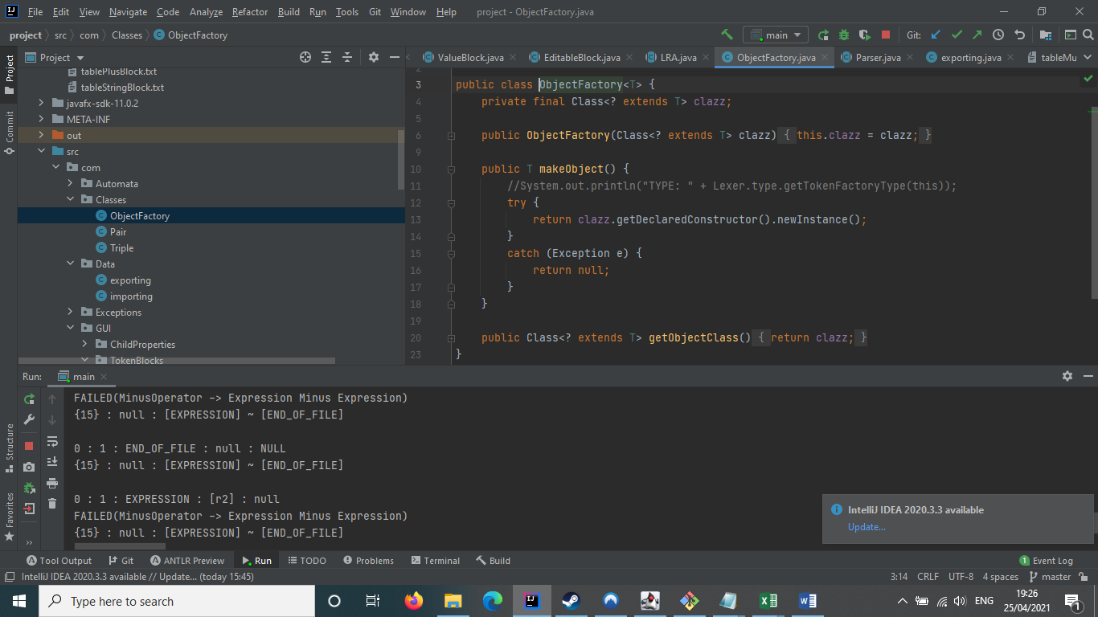

As can be seen in figure 16, ObjectFactory takes a class object of its generic class and, using reflection, creates a new instance of the class object.

ObjectFactory<> is used in abstract syntax tree creation, with each of the empty concise tokens created using the Lexer’s ‘type’ enumeration’s factories linked to each of the token types. It is also used the graphical interface to create new token blocks (see *Token Block Analysis* in *Graphical User Interface*).

### Factory Methods and the Abstract Syntax Tree

When creating the abstract syntax tree from the concrete one, multiple different factory methods are utilised, weaving together to recursively construct the tree’s concise token nodes from the CST’s context tokens. These methods, namely construct(), buildFromToken() and buildChildren(), are listed below.

|  |  |  |
| --- | --- | --- |
| METHOD | DEFINED IN CLASS | PURPOSE |
| construct | All concise token classes | Different for every concise token. Will generally attempt to buildChildren() using the partner concrete token used for its factory creation. Will always return itself. |
| buildFromToken | Token superclass | Attempts to create an empty concise token object from the Lexer’s ObjectFactory<> for its type, construct() it and return it. If it cannot, it will return the results of buildChildren(). |
| buildChildren | Token superclass | Returns a list of all of its children’s buildFromToken() results. |

The result of these functions is a tree that loses many of the superfluous token nodes that were present in the concrete syntax tree. This abstract syntax tree is utilised in the execution of semantic actions, as explored below.

## Semantic Actions

The program’s ability to execute emerges from its implementation of semantic actions. These actions are each tied to a specific concise token class, and allow each token to perform specific behaviours. For example, a PlusOperator node could return the sum of its two Expression children.

### Visitor Patterns

Semantic actions are implemented utilising a visitor class pattern. A visitor pattern is a construct that ensures that "*software entities (classes, modules, functions, etc.) should be open for extension, but closed for modification*" [13]. Visitor patterns ensure that while a class can have extensions to its features, it cannot have its source code altered. Visitor patterns also allow for organised grouping of class behaviours, which is why I used them for semantic actions. The particular visitor pattern implementation I used for semantic actions was taken from “Modern Compiler Implementation in Java”, by Andrew W. Appel. It utilises an interface to create a concrete interpreter class, which is what defines the behaviours.

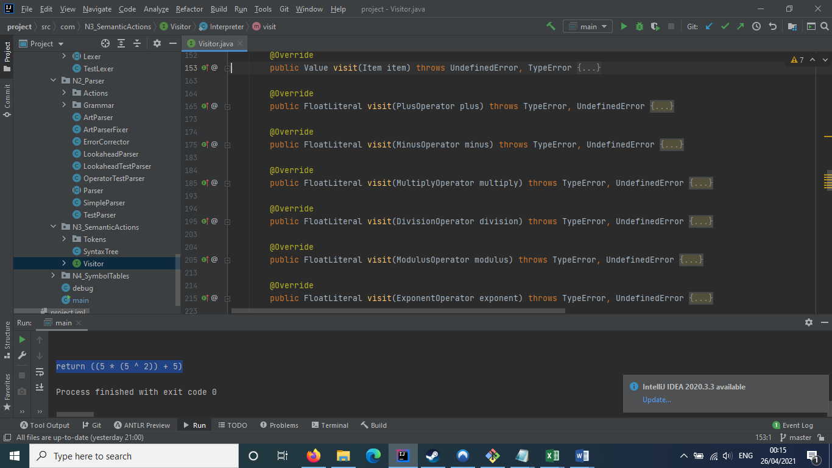

⌂ Figure 17

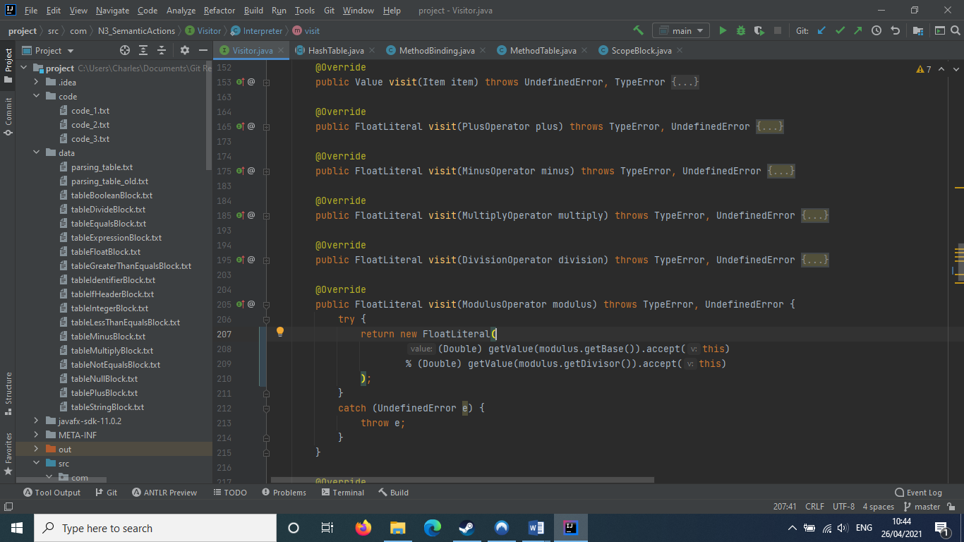

⌂ Figure 18

As can be seen in figure 17, the Visitor class contains many visit() methods. These visit() methods specifically contain a single parameter of the specific concise token they are bound to. Figure 18 shows the visit() method for the ModulusOperator token, and as can be seen, it returns a new FloatLiteral token, of an % operation performed on the ModulusOperator token’s children.

To call these visit() methods, each concise token has an accept() method, as can be seen in figure 19. As seen in figure 18, these accept methods can also be called in visit methods to chain semantic actions together. This is how the AST is traversed.

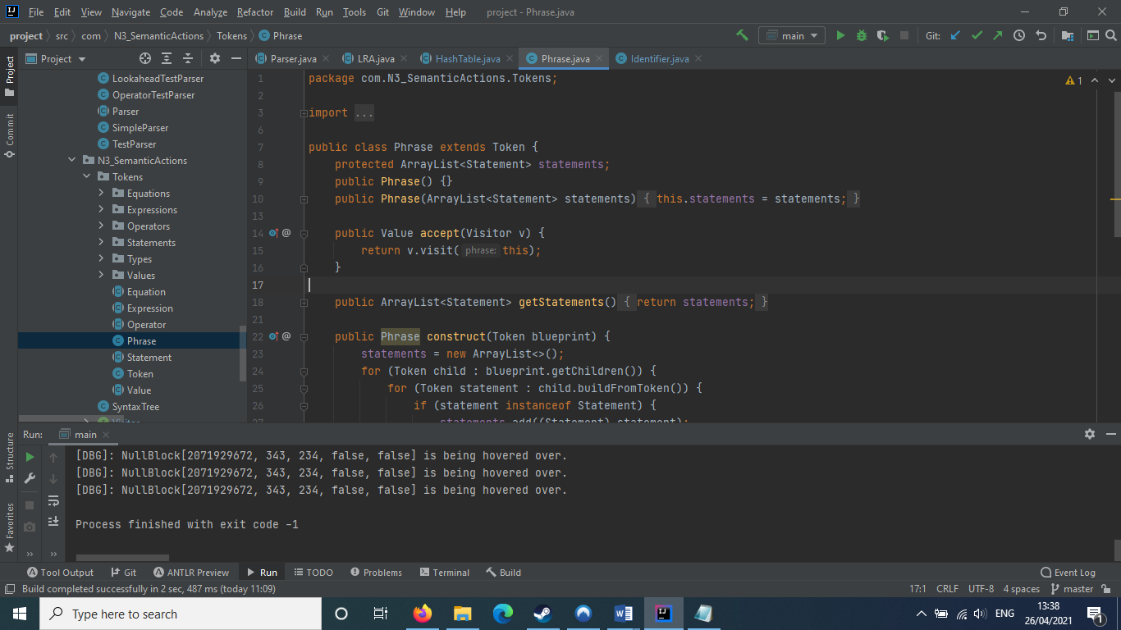

⌂ Figure 19

### Symbol Tables

To implement symbol tables into my interpreter, I took the hash-table based infrastructure found in Andrew W. Appel’s “Modern Compiler Implementation in Java”, and heavily adapted it, genericising it for use with methods as well as variables.

Hash-based symbol tables utilise a bucket list, which is a 256-index array built to hold Bucket<> objects that describe structures through an Identifier name. It implements methods insert() (seen in figure 20), lookup() (seen in figure 21) and pop() (seen in figure 22).

When attempting to determine where in the bucket an Identifier is located, the hash table utilises the Identifier’s hashCode function, wrapping around the length of the list.

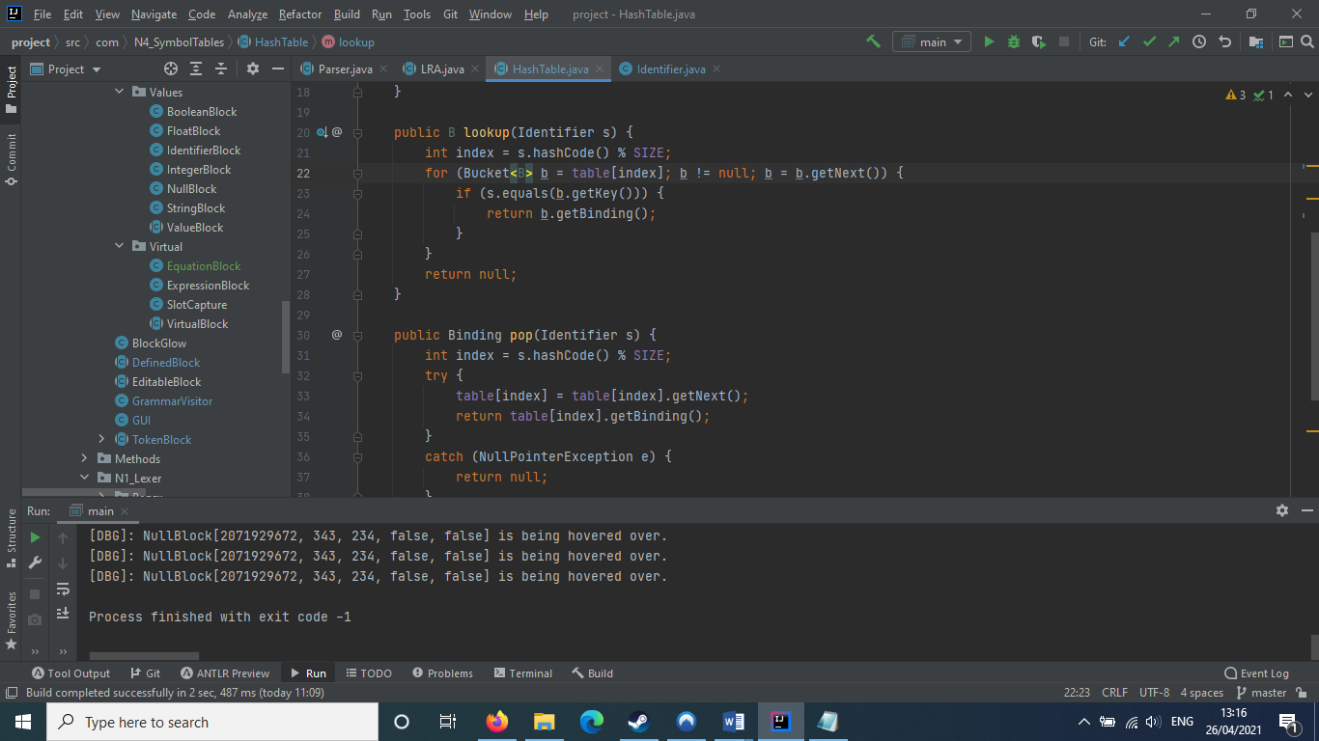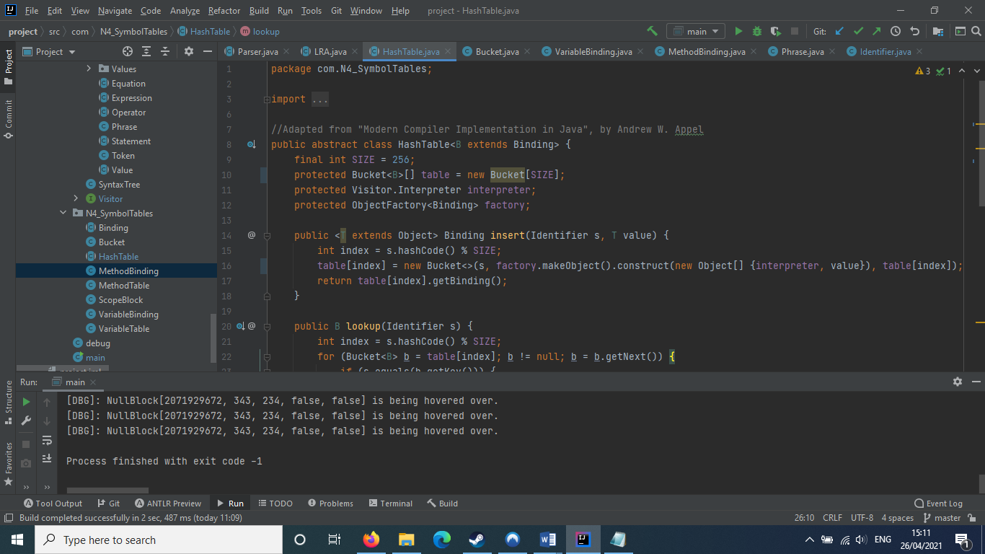

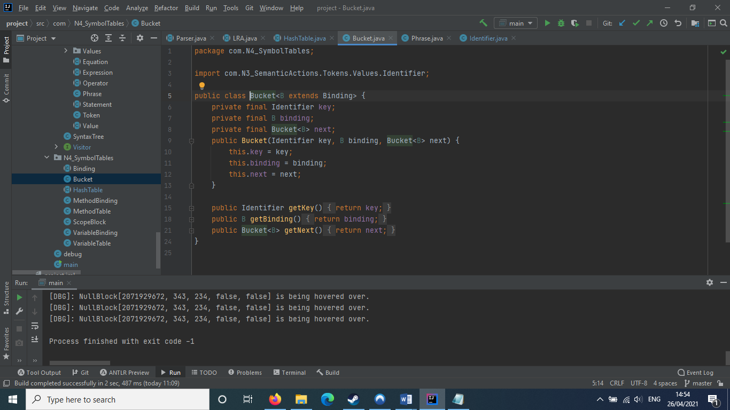  
Buckets hold an Identifier key, and a value in the form of a Binding. There are multiple types of Binding, hence why Bucket is genericised.

In addition, Buckets also hold the value of the previous Bucket that occupied their space, creating a link-list based stack of Buckets.

Bindings are created by utilising object factories. As such, they utilise a construct() method, however unlike the Token class, the Binding class’ construct method takes a list of objects as a parameter.

|  |  |  |
| --- | --- | --- |
| BINDING | USED IN TABLE | PURPOSE |
| VariableBinding | VariableTable | Holds the value of the variable Identifier it was assigned to at the time of its creation. |
| MethodBinding | MethodTable | Holds the method body associated with its method name, and also holds the list of arguments required to call its method. |
| ScopeBlock | MethodTable | Provides a barrier to prevent scope shifts from revoking changes that occurred to a variable name before the calling of a method in which it was a participant. |

The insert() method takes a variable name ‘s’ and a value ‘value’ as parameters. The method creates an empty Bucket<>, inserting it into the bucket list and linking it to the last Bucket<> to occupy its space and returning the new binding. Its code is shown in figure 20 below.

⌂ Figure 20

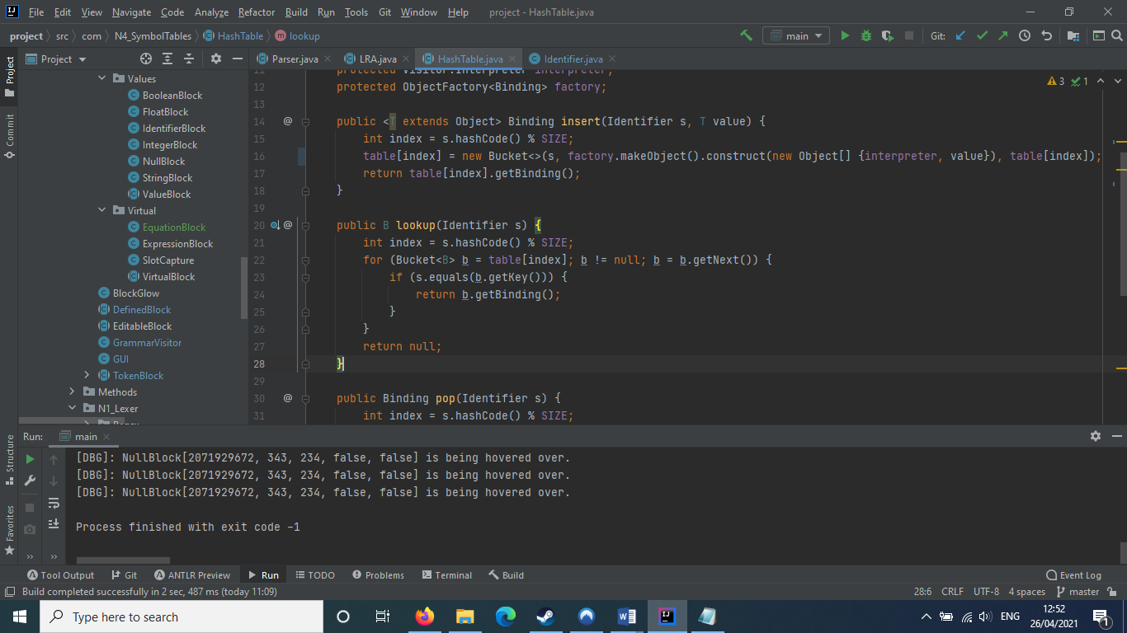

The lookup() method takes a variable name ‘s’ as a parameter. It attempts to run through the linked list of Buckets found at the name’s position in the bucket list going from latest to oldest, finding the first Bucket that matches the name and returning its binding. If it can’t find a Bucket, it returns null. Its code is shown in figure 21, to the left.

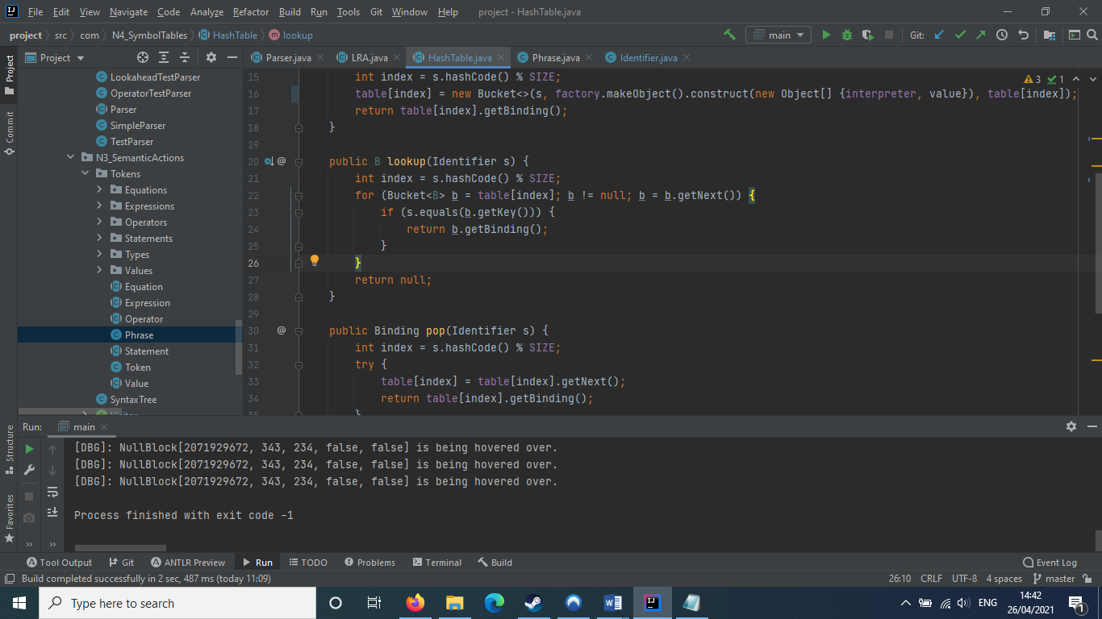

⌂ Figure 21

⌂ Figure 22

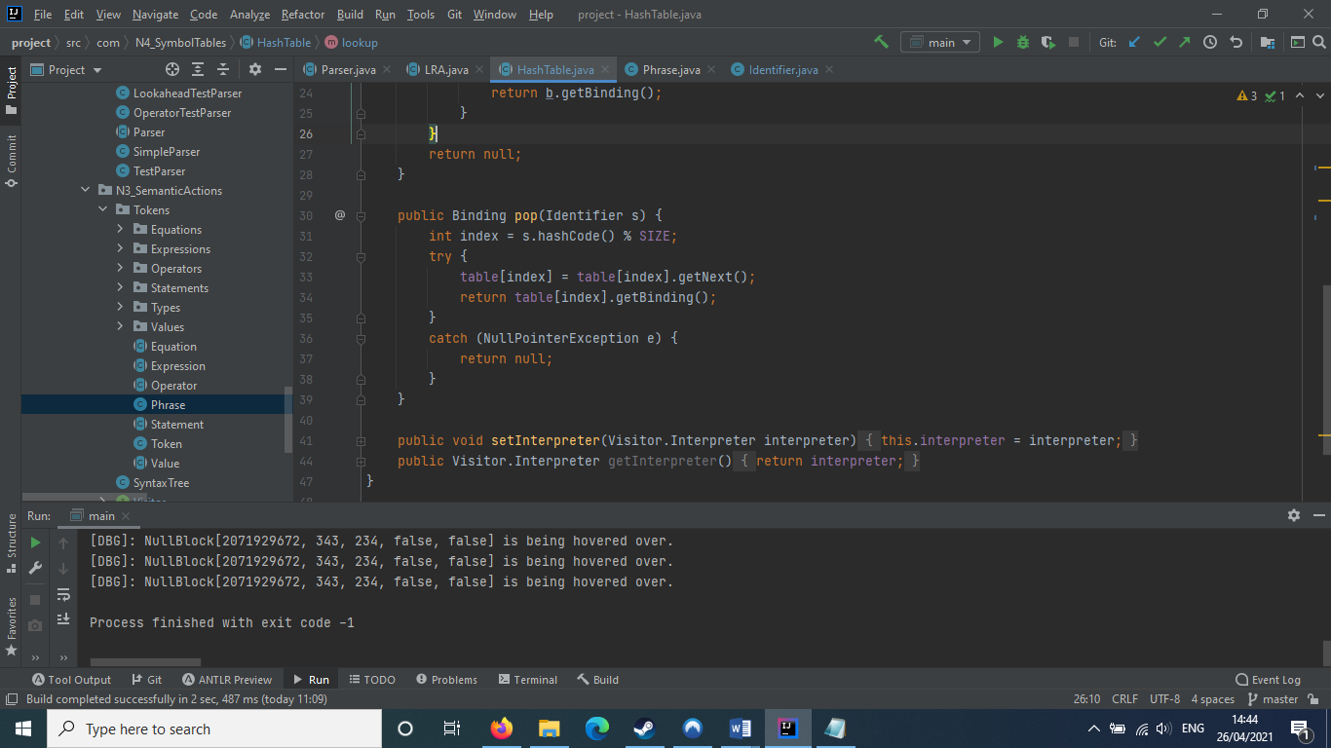

The pop() method takes a variable name ‘s’ as a parameter. It attempts to, similar to a stack, pop the top value from the linked list, placing the next value into the bucket list and returning its binding. If it cannot perform this action, it will return null. Its code is shown in figure 22, to the left.

## Graphical User Interface

To create the graphical interface, I used JavaFX, a Java software library used to build graphical software. It is an alternative to Java’s Swing and AWT libraries, although it can be used in concert with them as I have done.

### The Graphical Frame

To hold components such as shapes, buttons and forms, I utilised a JavaFX Scene object called ‘scene’, held in a JFXPanel called ‘jfx’, which was added to the program’s GUI class.

The GUI class also stores an ArtLexer for the analysis of block text, an ArtParser for use in allowing each block’s individual parser to copy its aliases, and an AnimationTimer to handle background step processes such as the gradual fading of flashing text and glows, the dynamic updating of tooltips, and the locking of slots.

### The Shape of Token Blocks

The model for a token block is formed using the shapes contained within JavaFX, and is stored within its own Group called ‘area’ to allow all of its components to to be manipulated as a whole. Whenever a temporary component like a block’s flashing text needs to be shown on the screen, it is added to the ‘area’.

Because of the fact that GUI components such as ‘area’ cannot be manipulated outside a GUI Thread without throwing an exception, Program.runLater() is always invoked when adding or removing components from ‘area’, as can be seen in figure 23.

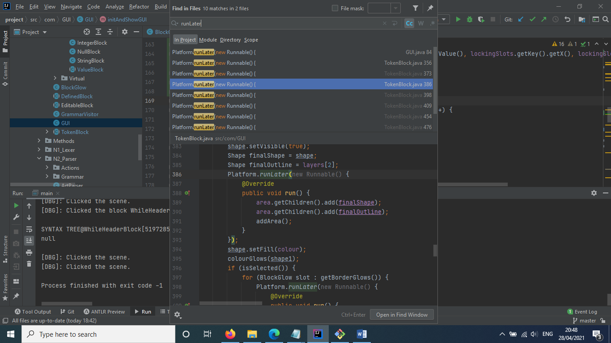

⌂ Figure 23

This model is created when the block is by calling setButtonShape(), and is recreated when it is changed in size. Every block also has a set of slots that can be used to connect them to other blocks. These slots have specific shapes, and can match to one other slot type that acts as a “lock” to their “key”.

Every slot also has side on the block that they appear at, either top, bottom, left or right. This affects their orientation, as well as which edge they are positioned on. A slot can only pair with a slot on the edge opposite to theirs. The table below gives a list of all possible slots.

|  |  |  |
| --- | --- | --- |
| SLOT | PARTNER SLOT | APPEARANCE |
| Rectangle | Rectangle | Straight edge. |
| Circle | Circle Slot | Semicircle, facing outwards. |
| Circle Slot | Circle | Cut out semicircle, facing inwards. |
| Dot | Dot Slot | A tiny green circle that hangs from the bottom of the block. |
| Dot Slot | Dot | Cut out tiny circle. |

Each block has a shape that composes their visible area. This shape is created when the block is, and is recreated when it is changed in size. To make a block’s shape, a rectangle is created. For each slot the block holds, pieces will continually be cut out of the rectangle using JavaFX’s union() and subtract() methods until all of the slots have cut a piece out. Figure 25 shows the code for this, and 24 shows a diagram of the creation of a Value block to demonstrate this.

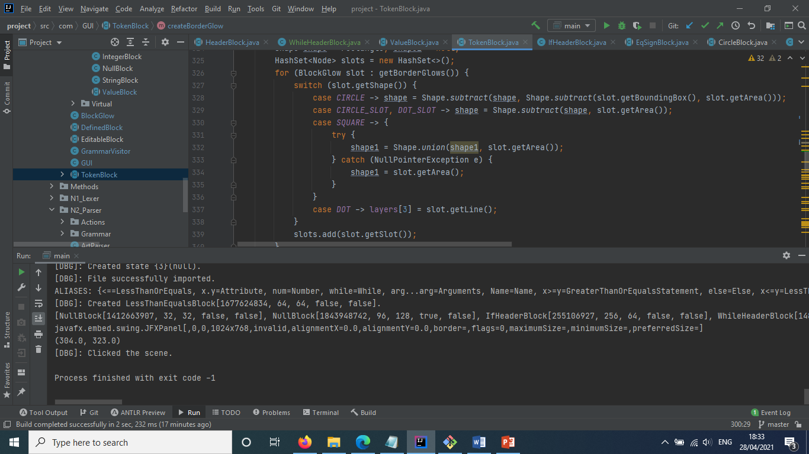

⌂ Figure 25

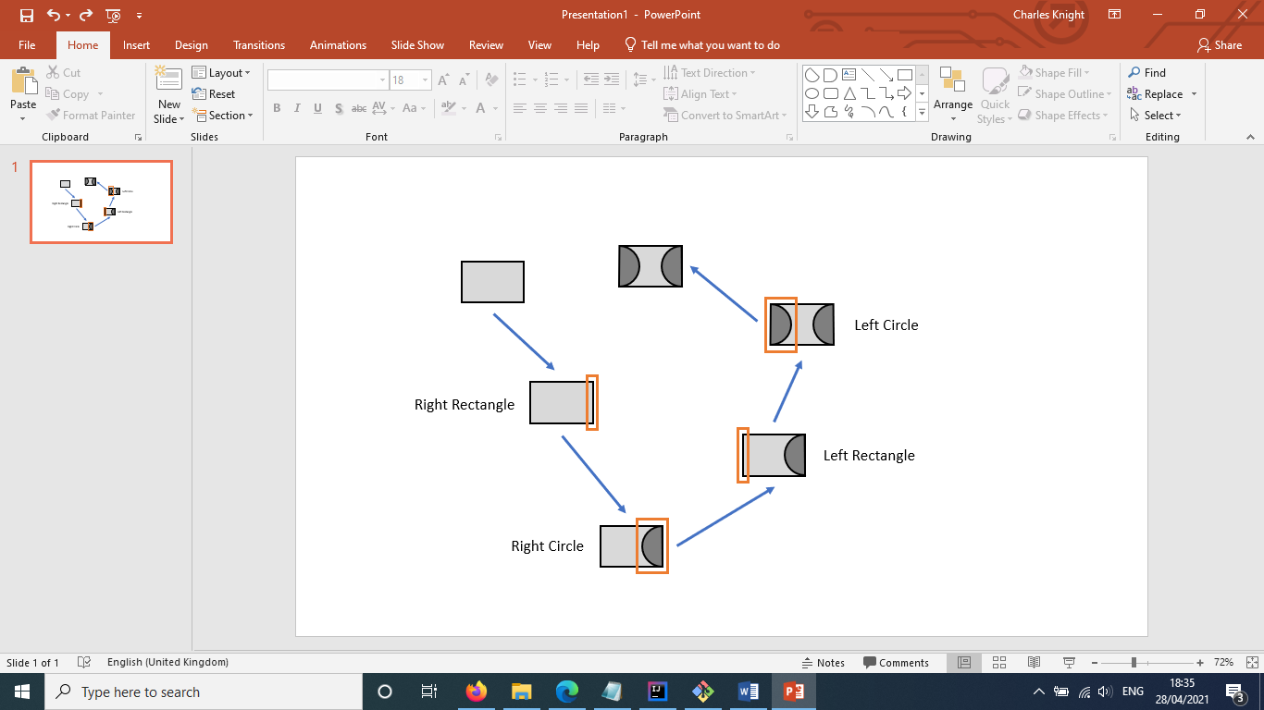

⌂ Figure 24

### User Interaction with Token Blocks

To allow the user to interact with token blocks, the GUI and TokenBlock classes define several actions that are tied to their ‘area’, as is explained in the table below.

|  |  |  |  |
| --- | --- | --- | --- |
| ACTION | DEFINED IN | TRIGGER | BEHAVIOUR |
| area.setOnMouseClicked | TokenBlock | Click on a token block. | Select the token block and print its SyntaxTree. |
| scene.setOnMouseClicked | GUI | Click on the canvas away from a token block. | Determines whether an EditableBlock has been edited. If so, analyse it using analyseText(). |
| area.setOnMouseDragged | TokenBlock | Drag the mouse on a token block. | Select the token block, dimming its glow and setting its location to the mouse’s position, allowing it to be pulled along. |
| area.setOnMouseReleased | TokenBlock | Release a mouse click on a token block. | If the scene has slots that are close enough to be locked, finalises those slots in preparation for them to be locked. |
| scene.setOnKeyPressed | GUI | Press any keyboard key. | Runs through each of the token blocks, finding if an EditableBlock has been selected. If it has, attempts to add the key to its text using EditableBlock’s addToInput(). |

### Block Text Analysis

When EditableBlocks have their text changed and the user confirms the change, the program will automatically attempt to analyse the edit, as can be seen in figure 26. This is done using a list of lexical tokens that all Blocks have.

As can also be seen, an EditableBlock’s addToInput() method utilises an analyse() method. This method is abstract, meaning that subclasses of EditableBlock, such as ValueBlock, utilise their own unique version of analyse().

⌂ Figure 26

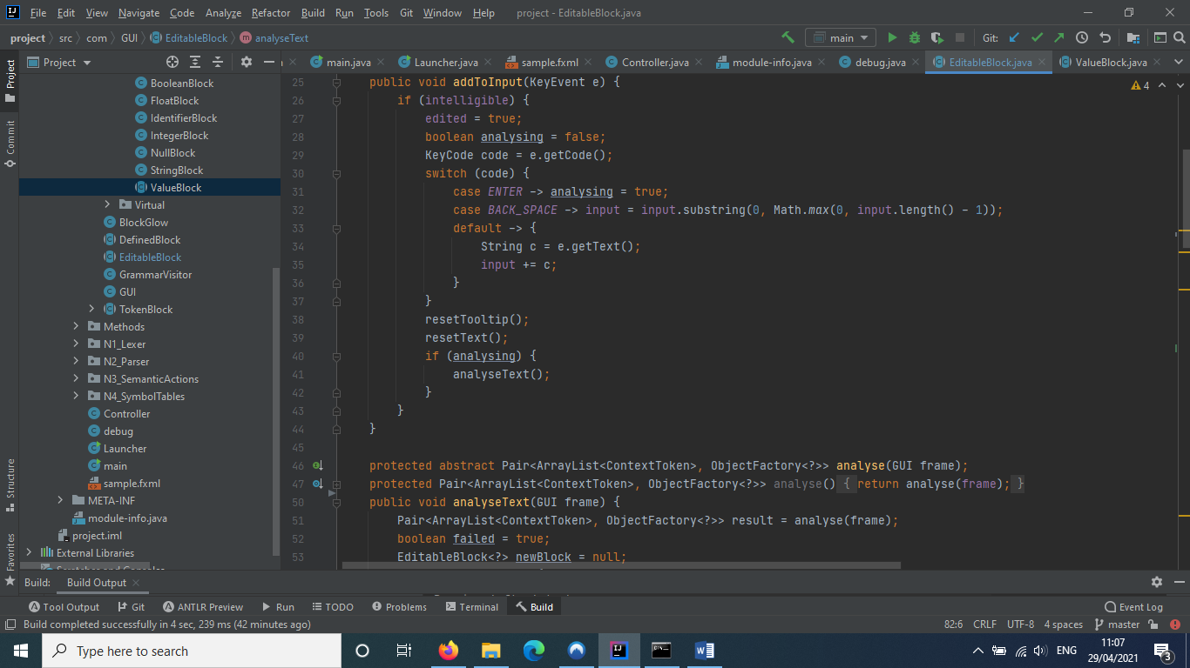

In ValueBlock’s case, analyse() utilises the GUI class’ ArtLexer to create a list of tokens from the Block’s text. If the Block is empty of text, it will automatically generate a list with a NULL token instead of using the Lexer. This counts as a succeeded analysis.

If the analysis succeeded, the ValueBlock will use the first token in the list to create a new type of ValueBlock using the ‘Lexer.type’ object factory, attempting to recreate its properties such as text, location and occupied slots in the new block. The token list that was found is assigned to the new block.

### Block Parsing

When any new EditableBlock is created or any Block is slotted, the program will attempt to assign the block or chain into a category by parsing its token list. This is done using a small parser that is unique to that specific Block, alongside its concise token, which is defined differently for each TokenBlock subclass.

The grammars of a Block’s parser are defined in a Block’s setGrammars() method. When a block’s slots are created, a position on one of the parser’s grammars may be specified, binding the slot to that grammar token. These methods are shown in figure 27.

To actually parse a block or chain. It first runs the createTokensFromSlots() method, attempting to obtain a list of context tokens it returns for use as the parser’s input. This method attempts to create lists of context tokens matching the grammars in the block’s parser, attempting to complete them using the concise tokens assigned to each of the blocks bound to the grammar’s bound slots. If it finds that none of the grammars have filled all of their bound slots, it will return null and flash each of the offending slots red. An example of this method’s execution can be seen in figure 28 below.

⌂ Figure 28

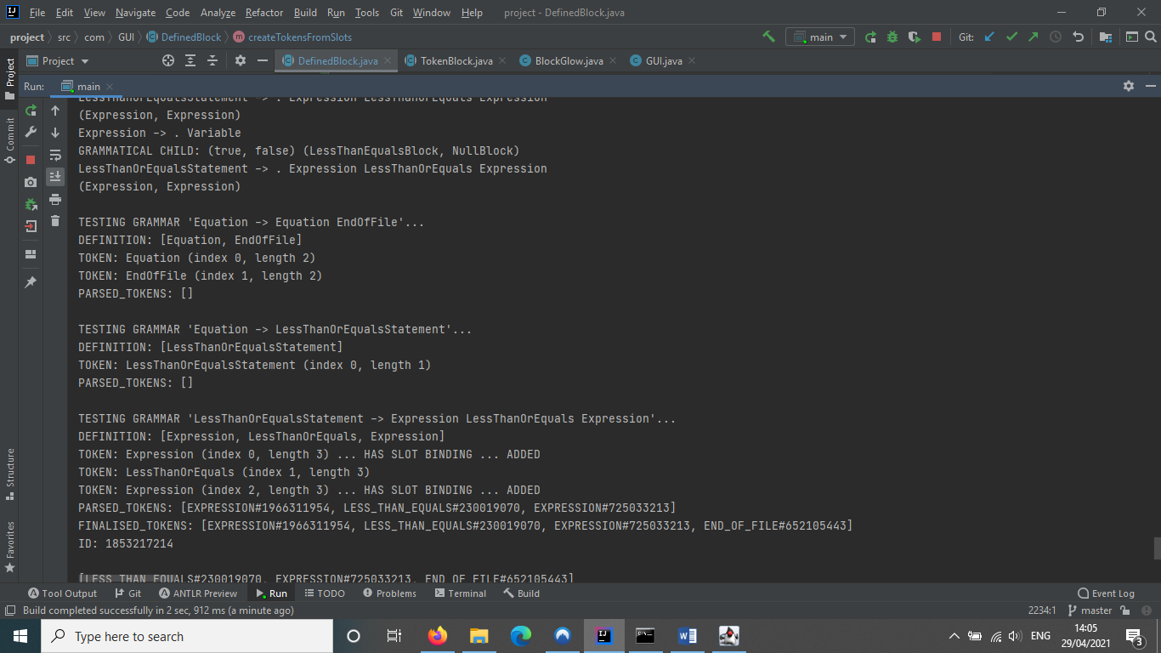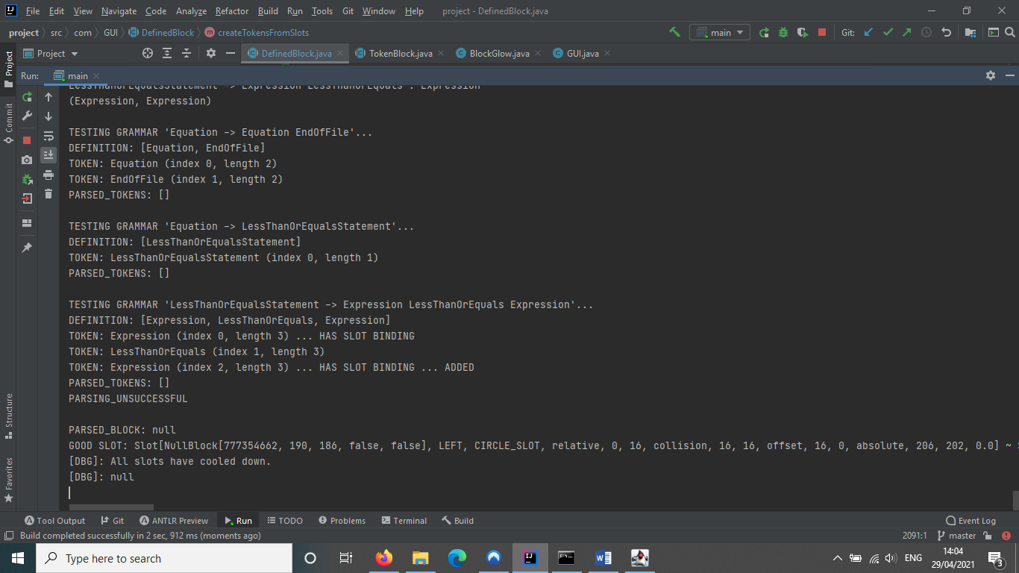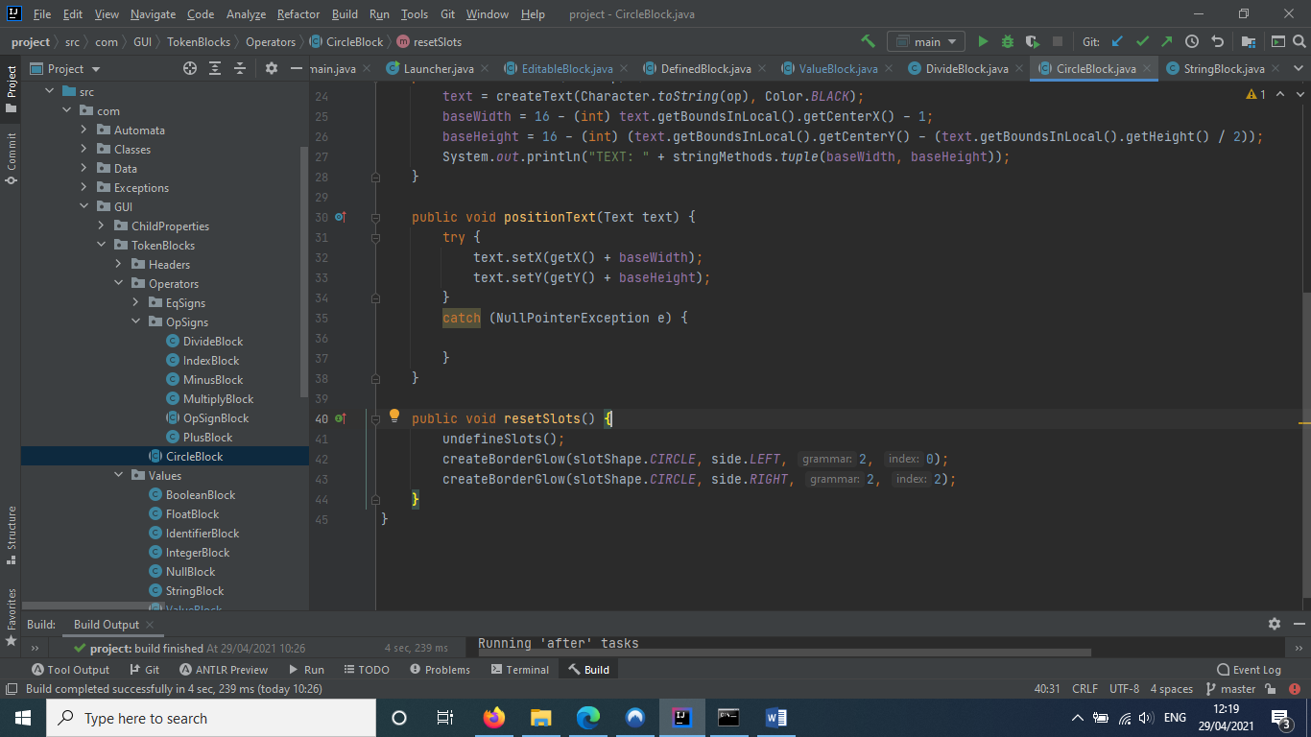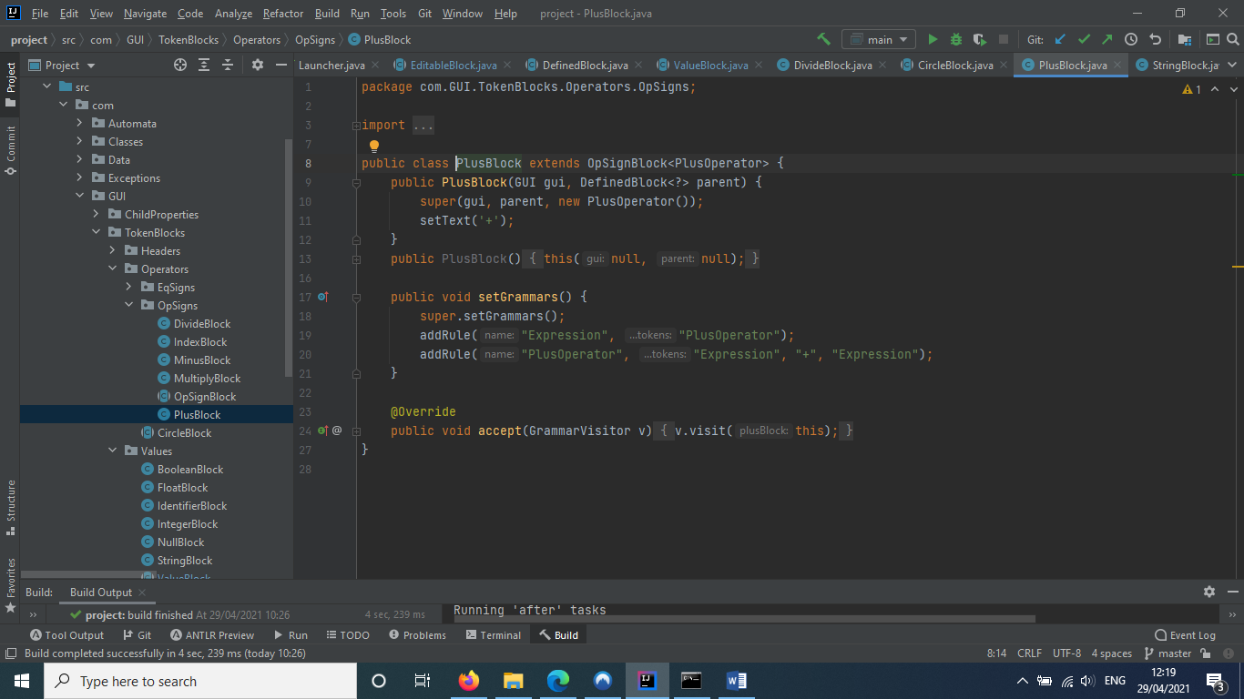

⌂ Figure 27

If the method returned a token list and not null, the Block will attempt to create a new Block using the result of its parser’s analysis of the list. If the parsing is a success, the Block will assign this new Block as its parent.

# Project Design and Structure

The code for my capstone project is structured and designed in an organized way, dichotomising the various separate mechanisms that it uses to function.

## Folder Structure

⌂ Figure 29

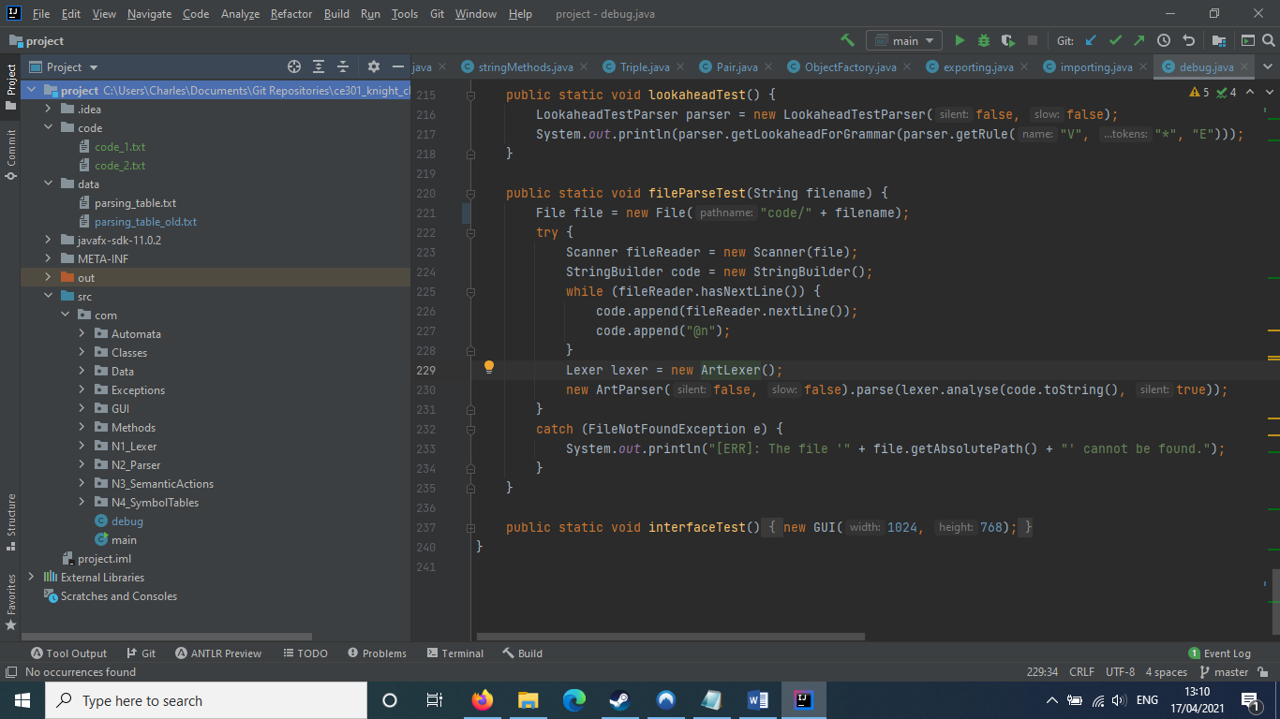

As can be seen in figure 29, the project is split into the various stages of an interpreter, as well as sections for automata, exceptions and the program’s GUI. There are also higher-level folders for target code and the program’s parsing tables. The purpose of each of these folders will be elaborated on in a table below.

The folder structure that can be seen here was naturally reinforced by the nature of by project. Because my project was mainly focused on creating a working code analyser, I knew that I had to work in sequential discrete stages. As such, I ensured that each stage was ordinally separated from the last not only in terms of the program’s temporal execution, but also in terms of their spatial separation as well. As can be seen, each of the folders for the stages is numbered to ensure that one stage follows after its predecessor – ‘N1_Lexer’ is placed before ‘N2_Parser’.

The nature of each of the folders can be seen below.

|  |  |  |
| --- | --- | --- |
| Folder | Purpose | Contains… |
| Automata | Contains classes for all the different types of automata that are used in my project. |  |
| Classes | Contains the classes for the miscellaneous but useful objects that allow things to run smoothly. |  |
| Data | Contains classes that hold static methods for managing data flow into and out of the program. |  |
| Exceptions | Contains all of the exception classes. |  |
| GUI | Contains all of the classes that relate to the graphical interface and block language. |  |
| Methods | Contains classes that hold static methods for miscellaneous but useful methods that allow things to run smoothly (e.g. a tuple-creator, or methods for dealing with complex math equations). |  |
| N1_Lexer | Contains all of the classes that relate to the lexical analysis stage of analysis. |  |
| N2_Parser | Contains all of the classes that relate to the parsing stage of analysis. |  |
| N3_SemanticActions | Contains all of the classes that relate to the interpreter’s abstract syntax tree. |  |
| N4_SymbolTables | Contains all of the classes that relate to the interpreter’s semantic actions and execution. |  |

## Class Structure

Because of the fact that the program’s interpreter stages are largely modular, the classes involved in the interpreter stages generally only interact within their own stage. However, all interpreter stages also have a single main class which interfaces with the next stage in the interpretation.

The class structure for the program’s automata can be seen in figure 30.

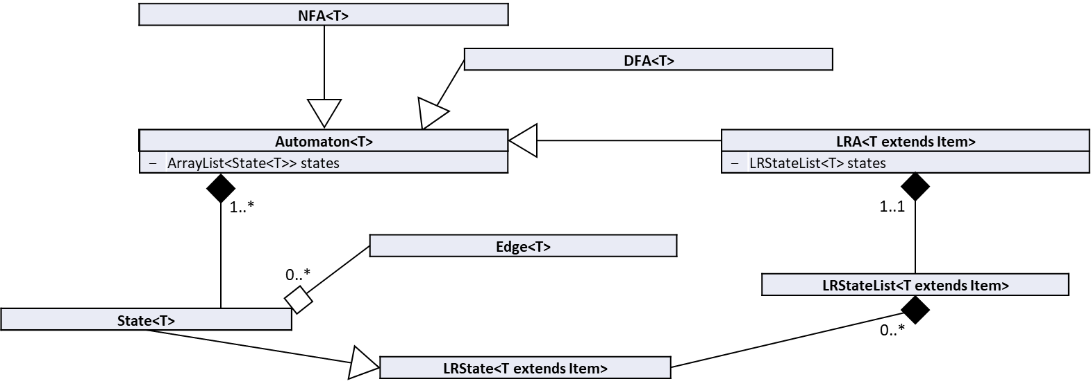

⌂ Figure 30

The class structure for the program’s regular expression classes can be seen below figure 31.

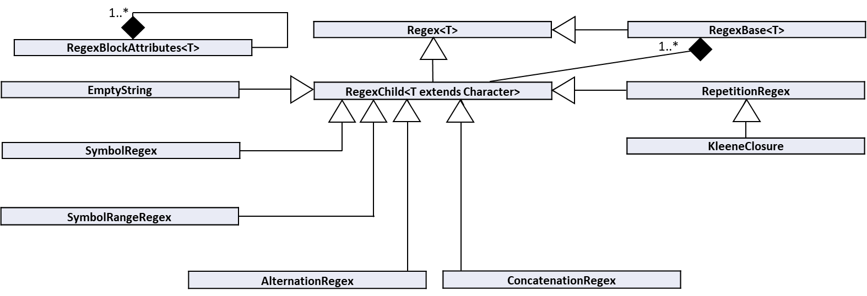

⌂ Figure 31

The class structure for the program’s lexical analyser can be seen in figure 32.

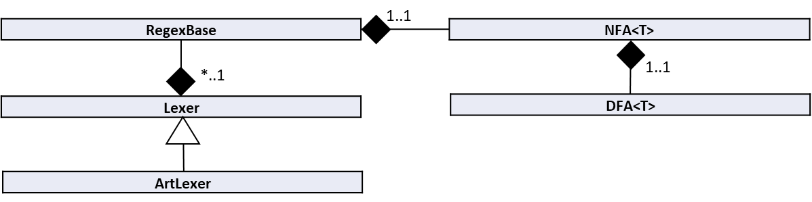

⌂ Figure 32

The class structure for the program’s syntax parser can be seen in figure 33.

⌂ Figure 33

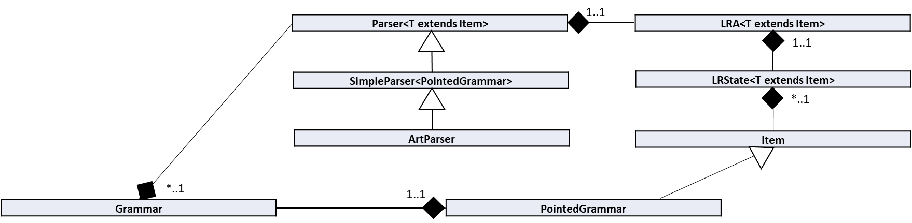

The class structure for the program’s abstract syntax tree can be seen in figure 34.

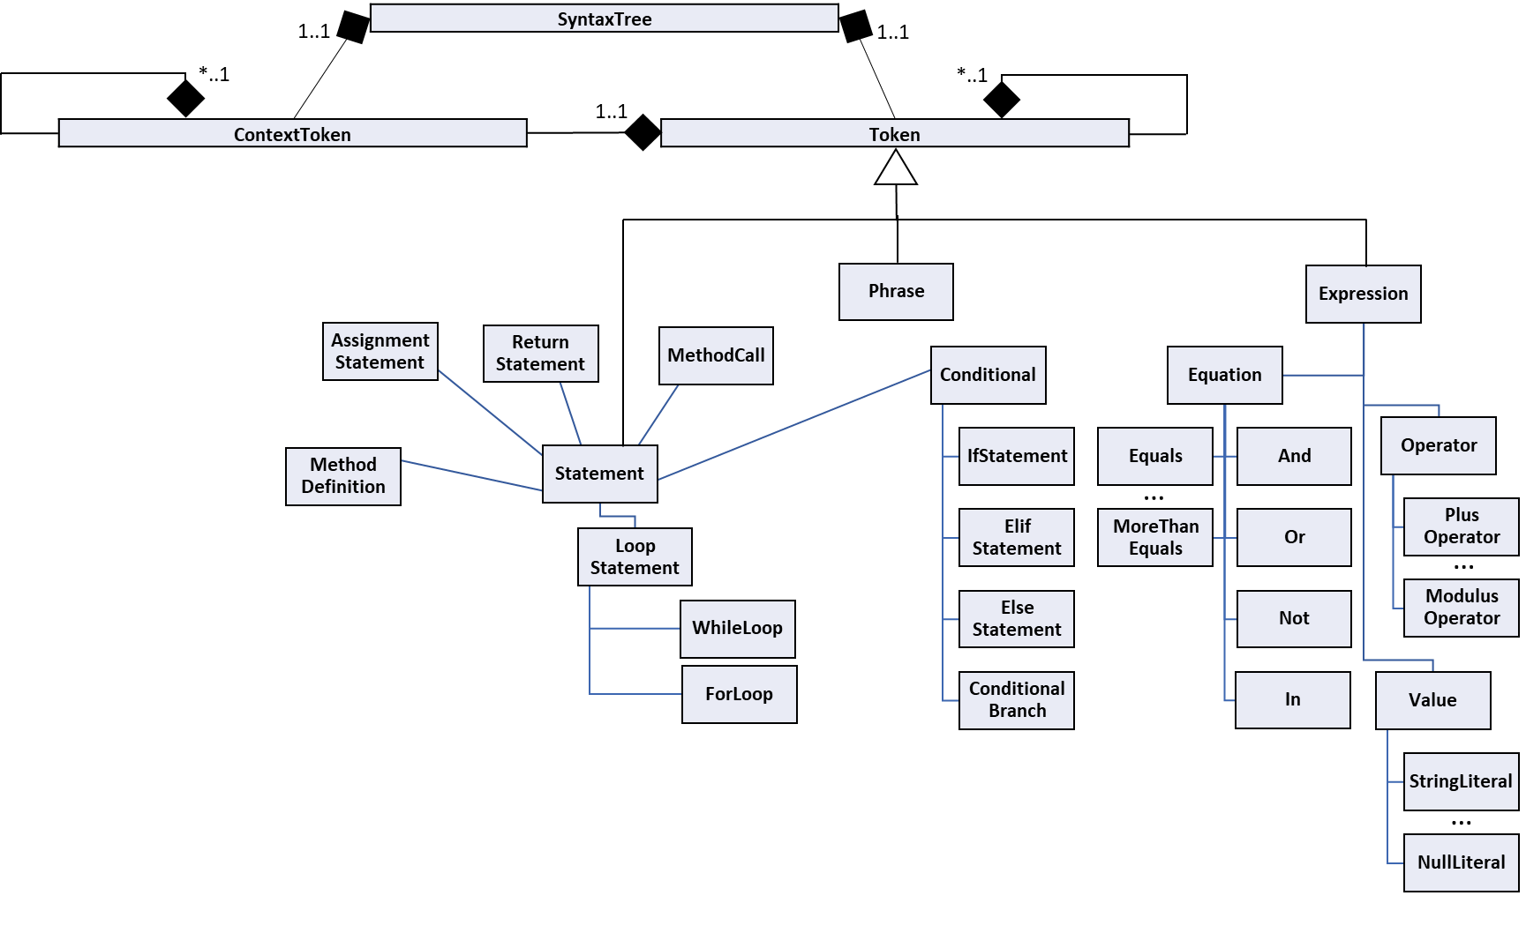

⌂ Figure 34

The class structure for the program’s semantic actions and symbol tables can be seen in figure 35.

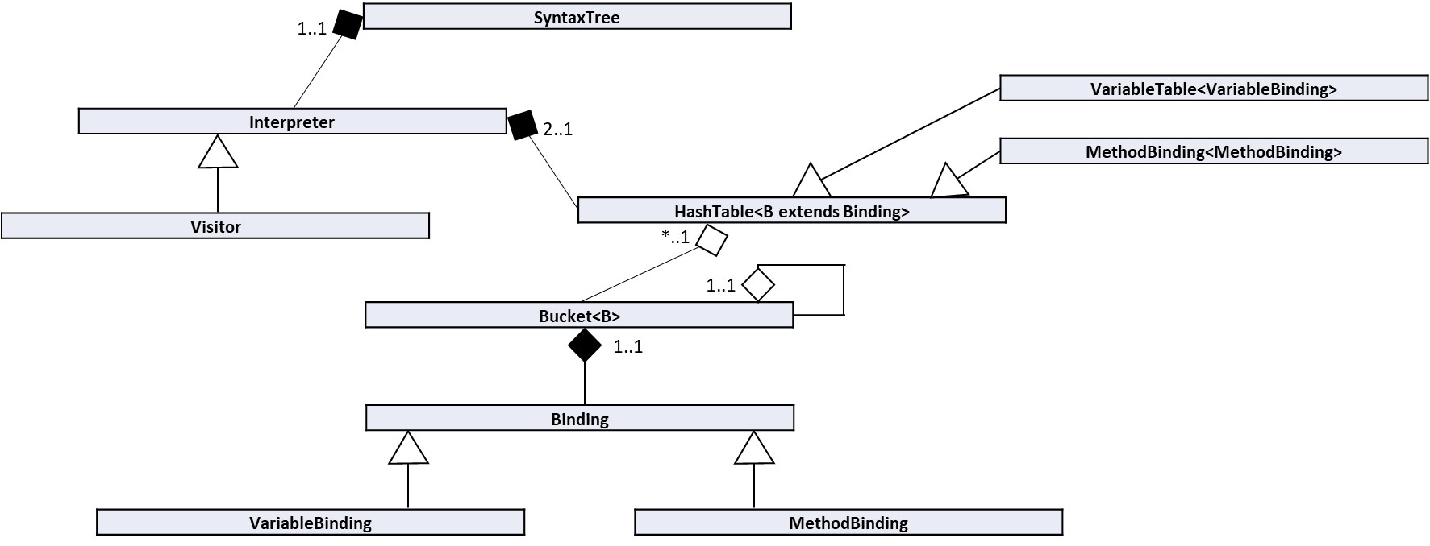

⌂ Figure 35

The class structure for the program’s graphical interface can be seen in figure 36.

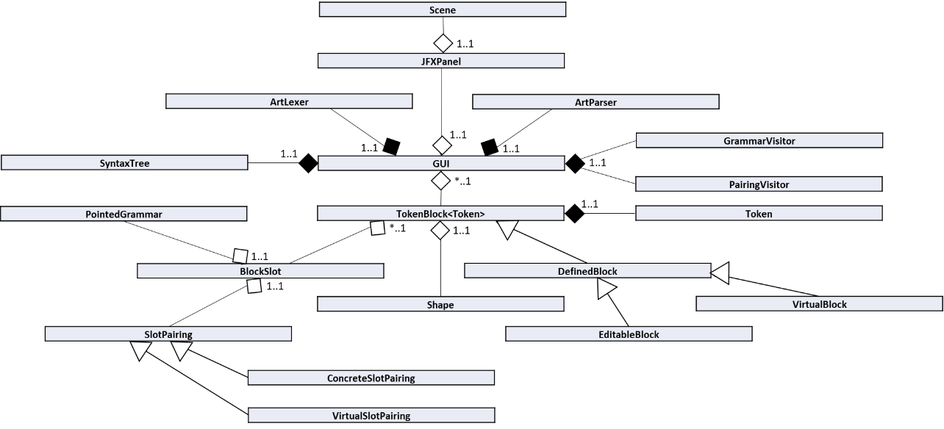

⌂ Figure 36

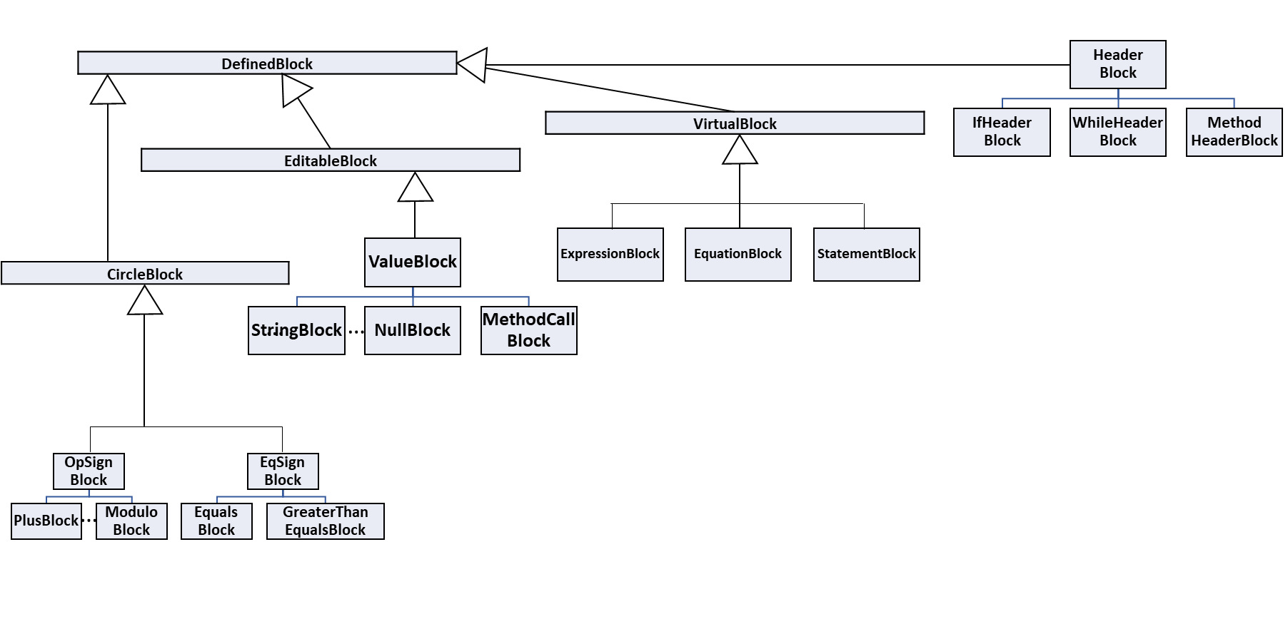The class structure for the program’s token blocks can be seen in figure 37.

⌂ Figure 37

# Testing

Throughout my project, I have had to program a variety of tests to ensure that my program was working as intended. Most of these tests are unit tests, but some of them are integration tests instead.

## Test-Focused Design

My program was built from the ground up to be simple to test. Its modular structure allowed for easy isolation of individual parts for unit testing, and its building block design meant that these individual parts could easily be strung together if an integration test needed to be performed. If a full-scale program test needed to be performed to observe the entire analysis process, these individual parts could easily be sequenced into a complete analysis of a code file. This is demonstrated in the structure and nature of each of the program’s tests, as will be shown in the following sections.

Each of the tests are invoked from the main function. To do this, it was necessary to change the value of a string variable called ‘test’. There are a variety of codes that the program will check for when the program is run, each of which correspond to a single test function. If ‘test’ was equal to any one of these codes, it would call its corresponding test function.

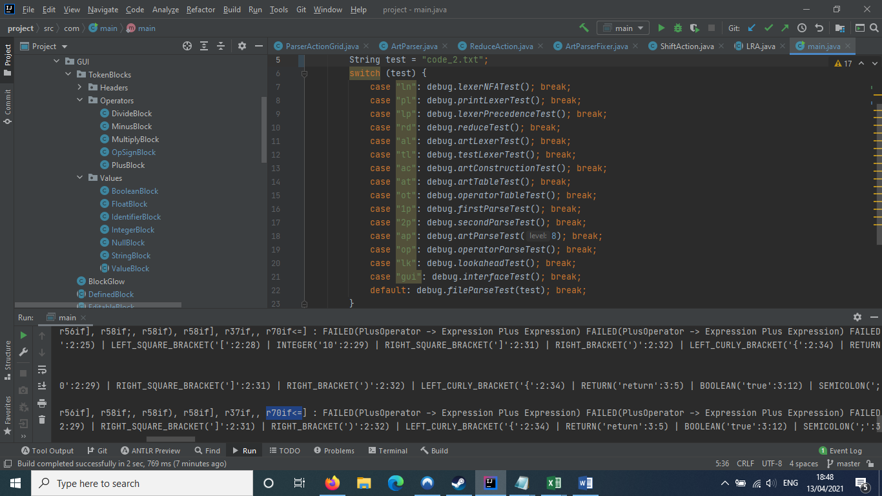

⌂ Figure 38

This can be seen in Figure 38. As can be seen, a switch statement is used here to check through each of the codes, until it defaults to running a file parse test, which runs through the entire program.

## Unit Testing

The unit tests I created to test my program can be seen below. These involve singular mechanisms or functions, and are relatively small scale compared to my integration tests.

|  |  |  |
| --- | --- | --- |
| Test | Code | Purpose |
| lexerNFA | ln | Prints out a list of states that composed the NFA’s for three separate tokens. |
| printLexer | pl | Prints out the results of a series of lexical analyses to test the regular expressions of important tokens. |
| equalPointedGrammar | eg | Creates a list of pairs of pointed grammars, some of which are equal and some of which aren’t. Tests each pair in the list to check that they are being compared properly. |
| closure | cl | Tests the output of the closure function that the parser uses to create new states in its DFA. |
| reduce | rd | Tests the behavior of the reduce action when applied to an artificial parsing session’s stack and input. |
| lookahead | lk | Tests how a lookahead (LR(1)) parser handles creating lookahead tokens for its DFA. |
| valueTest | va | Tests the string values of a series of Value concise tokens and compares them to their execution results. |

## Integration Testing

The integration tests I created to test my program can be seen below. These incorporate and mesh multiple separate mechanisms or functions, and test larger parts of the program.

|  |  |  |
| --- | --- | --- |
| Test | Code | Purpose |
| lexerPrecedence | lp | Tests how the lexer handles token precedence by checking the difference between keywords and other text. |
| artLexer | al | Tests how a strip of text-based code is lexically analysed by the main language’s lexer. |
| testLexer | tl | Tests how a strip of text-based code is lexically analysed by a test lexer. |
| artConstruction | ac | Tests how the main language’s parser handles constructing its parsing table. |
| artTable | at | Tests how long it takes for the main language’s parser to construct its table. |
| operatorTable | ot | Tests how long it takes for a small test language’s parser to construct its table. |
| firstParse | 1p | Tests how a test language parses through a series of already analysed tokens. |
| secondParse | 2p | Tests how a different test language parses through a series of already analysed tokens. |
| operatorParse | op | Lexically analyses a strip of text-based code, and tests how a parser specifically dealing with operations parses through it. |
| artParse | ap | Lexically analyses a strip of text-based code, and tests how the main language parses through it. This code strip is determined by an integer parameter. |

## Full-scale Testing

The full-scale tests I created can be seen below. These run through entire parts of the program, such that they test mechanisms that are the entire basis of the project.

|  |  |  |
| --- | --- | --- |
| Test | Code | Purpose |
| interface | gui | Runs the graphical interface. |
| fileParse | file | If supplied before the name of a text-based code file contained in the ‘code’ directory, runs the interpreter's analysis sequence through the file. |

## Terminal Output

Throughout the execution of the program, there is a lot of output to the terminal. This is mainly used to test the program, especially with backend processes such as parsing and semantic execution. Examples of this can be seen below.

### Printing Objects

Many objects in my program have been designed to give important information when they are printed to the terminal. Of specific note here are automaton states, grammars, parsing actions and abstract tokens, as well as graphical token blocks and their block slots. The syntax and meaning of these outputs is all listed in the technical documentation.

### Parsing Table Construction

When constructing a new parsing table, the program will print out the results of attempting to move on from a state of the parser’s automaton, as can be seen in figure 39.

⌂ Figure 39

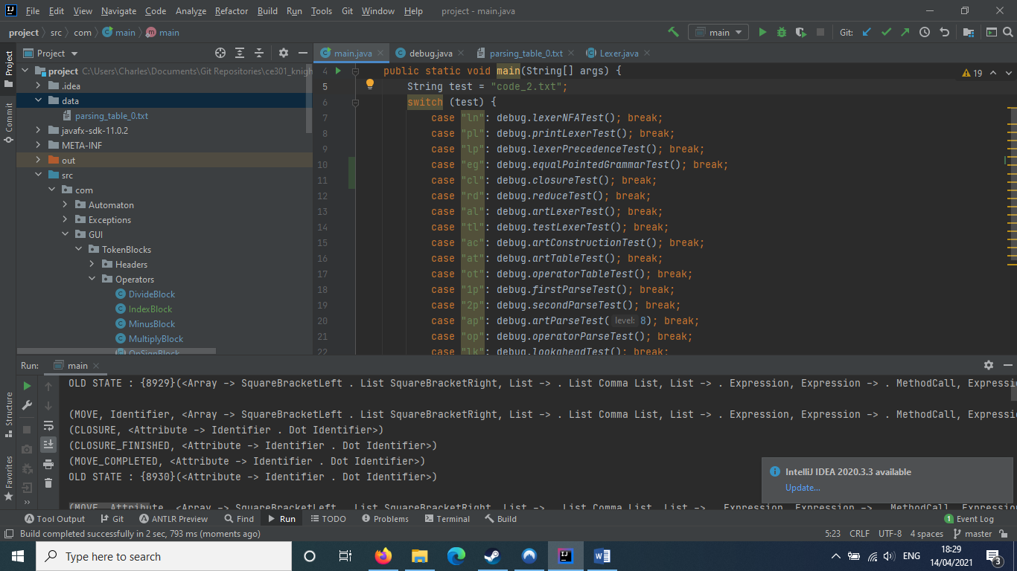

The meaning of this block of text is as follows.

* The information given in the ‘MOVE’ line prints out all of the grammars of the state that is currently being analysed in the parser’s automaton. Note that they are all pointed grammars, as they are going to have a closure performed on them.
* The ‘CLOSURE’ line indicates which of the state’s grammars are being affected by a state closure.
* The ‘CLOSURE_FINISHED’ line indicates the result of the closure.
* The ‘MOVE_COMPLETED’ line indicates what the new list of grammars are that will be turned into a new state.
* The ‘OLD_STATE’ line refers to the fact that there is already a state in the automaton with this grammar configuration, and as such the constructor will link the state referenced in the ‘MOVE’ line with this old state via a transition.

At the end of the table’s construction, the parser will print it, as can be seen below in figure 40 (note that this is not the full parsing table).

⌂ Figure 40

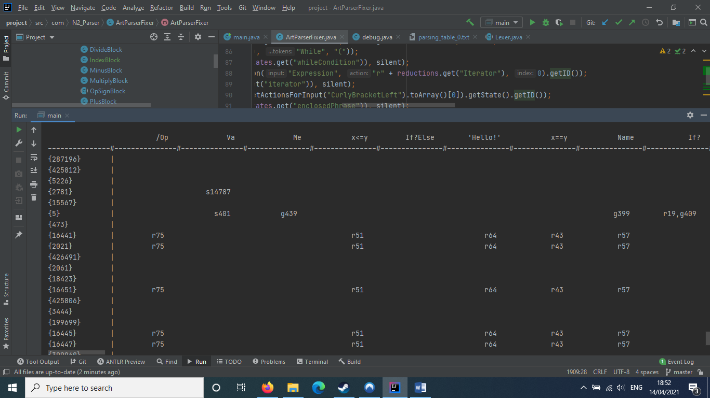

As can be seen, lengthy token names have been shortened to understandable symbolic labels for the column headers, and actions are ordered neatly allowing their placement to be simply understood. This ensures that a complex table is at least somewhat digestible and usable to grasp patterns from. This output was vital in my alterations of the full table, in spite of its complexity.

In addition, the constructor also prints out a list of the parser’s meaningful states, as can be seen in figure 41. As can be seen, states are printed in tuples, with a state’s number ID’s printed next to its meaning.

⌂ Figure 41

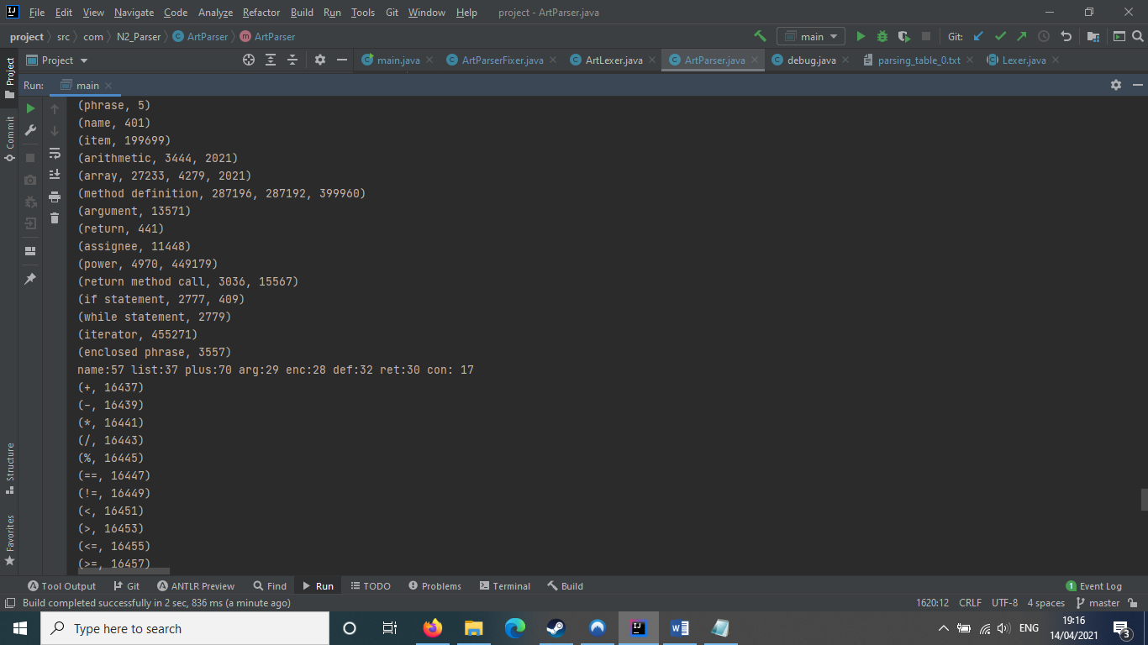

This was also incredibly useful, as it allowed me to make meaningful decisions when altering my parsing table, and also helped me see greater patterns when looking through the table as well.

Each of these states was obtained programmatically by looking for reductions and specific inputs, so I could look through the parsing table looking for these states to see connections on the macroscale.

### Code Parsing

When parsing a piece of lexically analysed code, the LR parser will print output at each stage of the parsing process. This can be seen in figure 42 below.

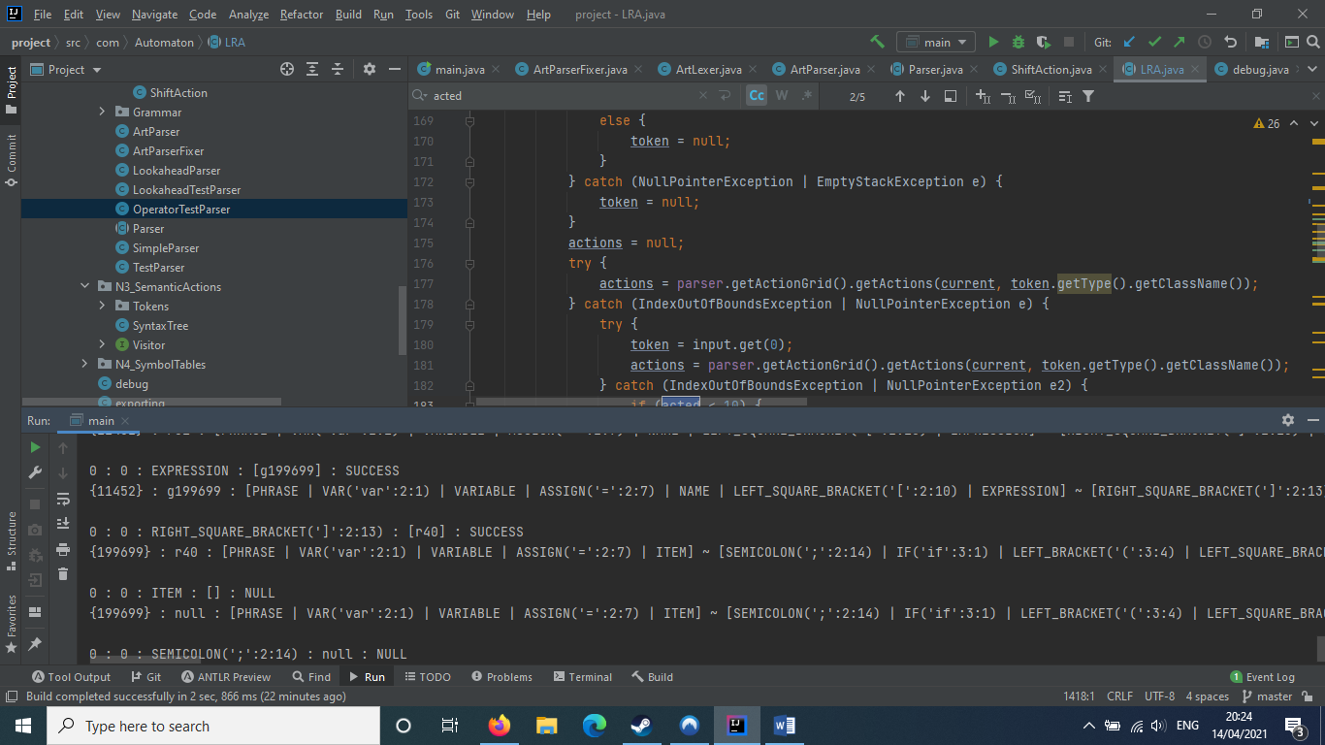

⌂ Figure 42

The syntax for each of the blocks is as follows.

**LEVEL** : **ACTED** : **TOKEN** : [**…ACTIONS**] : **…RESULTS**  
**STATE** : **ACTION_CHOSEN** : [**…STACK**] ~ [**…INPUT**]

* LEVEL refers to the number recursive calls deep the traversal function is into its parsing.
* ACTED refers to the number of levels the parser has run through since it has been able to perform an action.
* TOKEN refers to the lexical token that is currently being analysed.
* STATE refers to the current state of the automaton.
* …ACTIONS refers to the array of parser actions contained within the cell at row STATE and column TOKEN of the parsing table.
* …RESULTS refers to the array of results, either ‘FAILURE’ or ‘SUCCESS’, of each of the actions performed on the input and stack. ‘NULL’ means that there is no possible action that can be performed from the current cell.
* ACTION_CHOSEN refers to the single one of the actions from the current cell that has been able to alter the stack.
* …STACK refers to the array of tokens in the parsing stack.
* …INPUT refers to the array of tokens in the parsing input.

This has provided a massive help in trying to debug parsing issues. Through this output, it has been easy to diagnose the location and nature of a breakdown in parsing, and use that to alter the language and parsing table to correct the issue.

# Project Planning

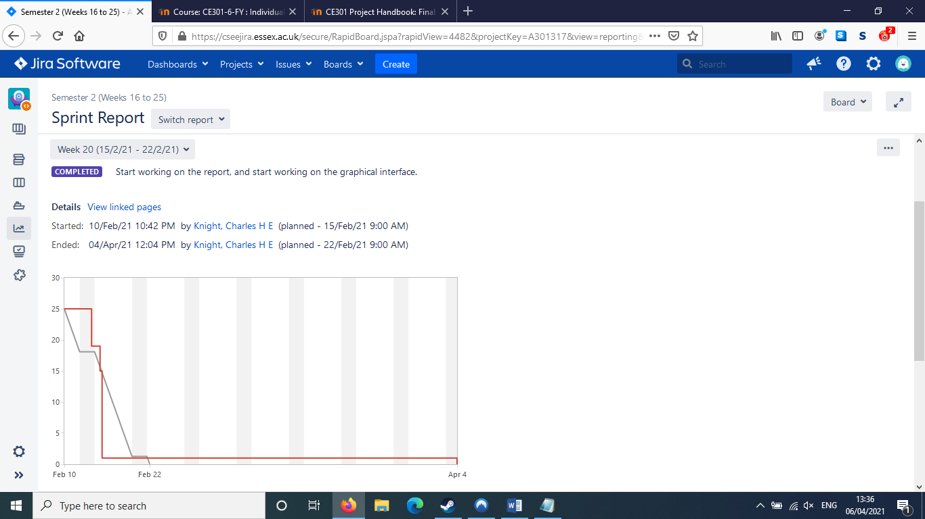

⌂ Figure 44

Although I had a clear direction and goals throughout the project, my week-by-week planning and routine was somewhat staggered. There were different times throughout the year where I focused solely on the capstone project, and other times where I did not update it at all, shifting my focus instead towards my other subjects that needed my attention. In addition, progress did begin to stall and falter towards the end of its lifetime.

## Jira Documentation

At the start of the term, I created a number of epics on Jira that described my large-scale goals in the project. These described the four stages of the compiler, as I knew that I needed to focus on each one in order. At the start of the easter break, I also created two more epics, to do with the report and the GUI, as that is when I fully started focusing on the capstone project again.

Figure 43 shows each of the epics I created, alongside some of the latest tasks with epics assigned to them. I would categorise all tasks I documented on Jira with which epic they belonged to, to remind myself of which area of the program I needed to focus on.

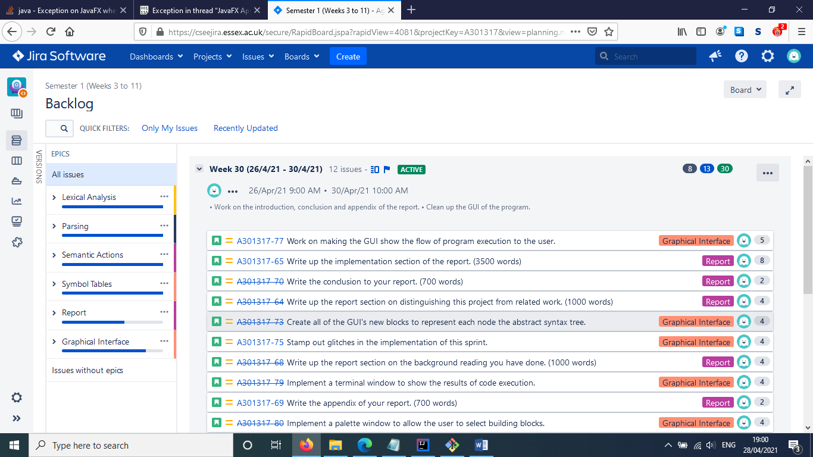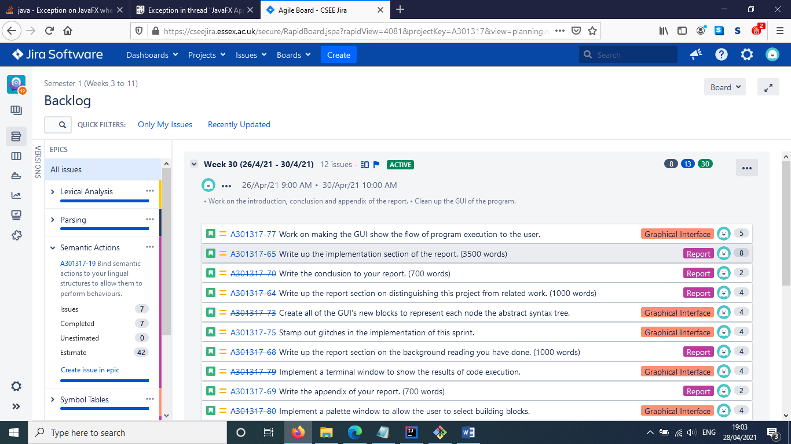

⌂ Figure 43

However, despite my macroscale vision, an issue that presented itself because of the staggered approach I took was its effect on my sprint documentation. While my momentum moved me through periods of intense focus on the capstone project, I would regularly update my tasks, while also ensuring that I would mark them as completed when I had actually finished them.

However, when it came time for me to turn my attention towards other, more urgent pursuits, my sole focus on the newly developed issue would lead to me forgetting to close the tasks for this project that I had most recently set for myself. This led to the documentation appearing to show them dragging on for inordinate amounts of time, stretching throughout my breaks in progress. A particularly egregious example of this can be clearly seen in the image below.

Figure 44 shows the sprint report for the final sprint undertaken in the spring semester. The green block represents time assigned to the sprint, whereas the red block represents all of the time that it had been left unresolved after it should have been closed.

It was supposed to end on the 22nd of February, and most of the tasks had been finished by then. Only two remained which, as can be seen, contributed very little to the overall effort the sprint required.

This highlights a larger issue however. Although I would plan out my sprints quite carefully, I would often sideline reporting their end them in favour of continuing my work. This led to many times where I would leave tasks unfinished, until I would end up performing a large cleanup of my Jira repository at some later point in time. This led to many of my sprint graphs looking rather strange, an example of which can be seen in figure 45. Note that aside from A301317-51, each of the tasks were actually completed by the sprint’s completion, and were since been marked as done.

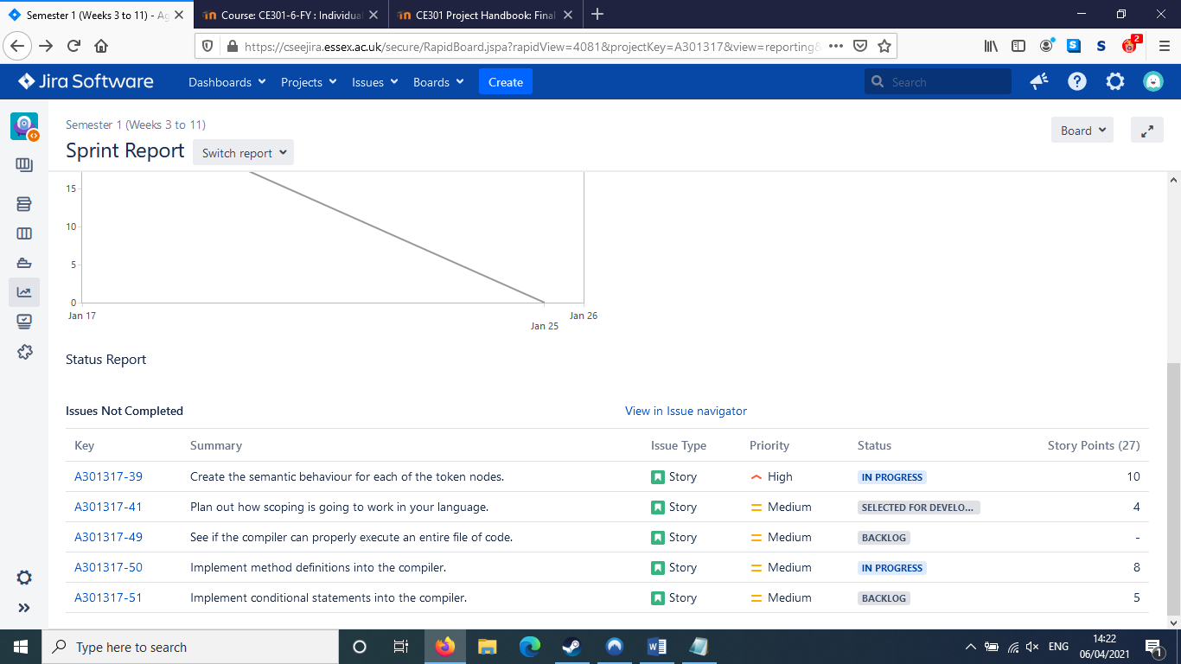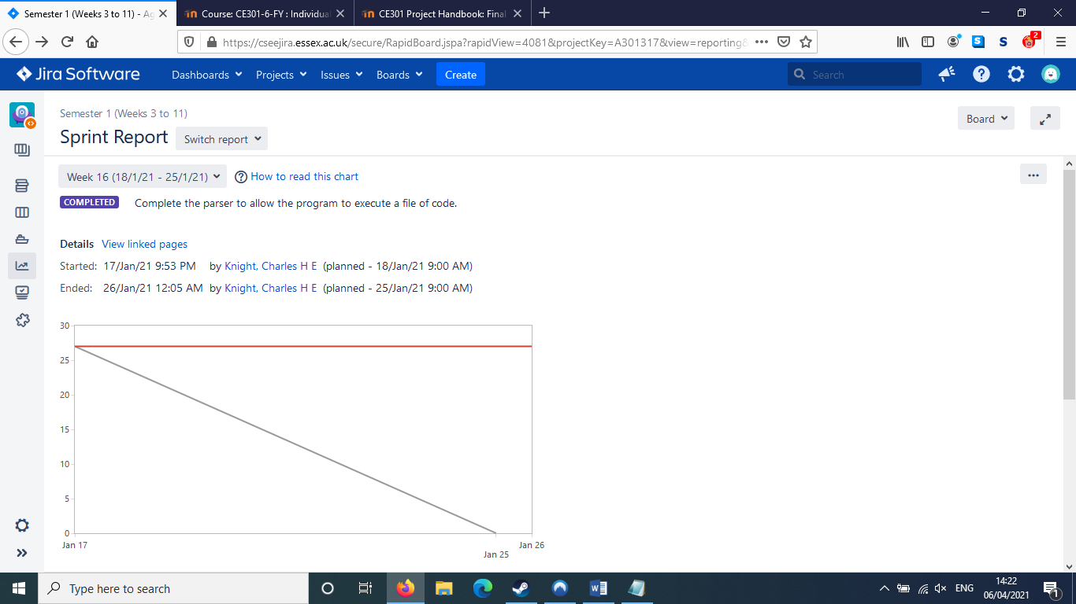

⌂ Figure 45

## Project change and adaptation

Throughout the project, various issues arose which impeded my progress. Mostly, they simply involved glitches that prevented a timely implementation of certain features, and were generally solved by working on other aspects of the program for a while before arriving back to the initial issue. This was able to be done because of the modular nature of my project. Because of the fact that stages could be easily isolated from each other and worked on separately, bugs in one area of the program would not cause effects on a different area. This meant that problems that plagued me in one area would not be felt in another, allowing me to compartmentalize and create new solutions to problems that had previously been persistent.

This could be clearly seen when I began to work on symbol tables. Originally, I had been working on trying to implement a lookahead parser to make the language more powerful. My original method for implementing this was to introduce the common algorithm for turning LR(0) items into LR(1). However, whenever I would run the new parser to construct even simple grammars, it would stall for inordinate amounts of time, far longer than I was willing to accept. No matter what fix I implemented, nothing seemed to improve.

Because of this lack of progress and because of the realization of the need for the program to actually handle variable storage, I stalled work on the parser, attempting to refresh my mind by working on implementing symbol tables. When I came back to working on the parser, I was much more able to deal with the problems surrounding it than I had been before – as can be seen, I decided to abandon the lookahead parser, instead evolving the old parser with manual tweaks to its parsing table that altered certain reduce actions to look into the stack, as can be seen with figure 46 on the next page.

This implementation of manual workarounds to actively alter the parser beyond its formal capabilities would become a continuing theme in the project’s lifespan after this. The additions would become routine, and would generally be implemented after a new rule was added to the grammar. Generally, I would generally test that the parser worked with the new grammar, and would tweak the parser to fix it at the point that it broke.

parser.getActionGrid().replaceAction(  
"r" + reductions.get("If Statement -> Conditional Tree"),  
"r" + reductions.get("If Statement -> Conditional Tree") + "if;");

⌂ Figure 46

## Risk Management

There were a few large issues that popped up throughout the project’s lifespan, however the structure I had decided to utilise made them rather painless to handle. One example of this is the large change in the direction of my project that happened in January.

### The January Scope Change

This change revolved around the scope of my project, and the aims I had set for myself to complete. At first, my original project goal was to create a functioning compiler, however this had to be downgraded to instead focus on creating an interpreter for reasons of time. As such, I decided to request that I could change my working goal and project title, from “Designing a language, compiler and graphical interface for the creation of custom items in a tabletop RPG system” to “Designing a specification, interpreter and graphical interface for a visual programming language”. This allowed me to cut back on many things that would not strictly be necessary, while maintaining the proper spirit of my project with an intact final product. This ultimately reduced my workload and created a visible and viable endpoint to finish the project in good time.

Due to the nature of my project, this change was relatively seamless, despite the fact that it was a very large-scale alteration to the overall project scope. Because I was working in modular, sequential stages, I could easily remove later parts that would run me over time, as I had done here, without having to drastically rethink my overall strategy or rewrite major sections of code. This is what generally happened after the change – I simply continued moving forwards, not really focusing on refactoring things to adjust to the new project scope, as I didn’t need to.

### The Easter Break

However, the January scope change was not the only event to disturb the progress of my capstone project. Another, more tumultuous circumstance arrived at the end of the spring semester, and into the Easter break.

As I stated in the first part of this section, despite having a relatively steady flow of progress through the autumn semester and into the start of the spring semester, things started to slow down towards the end of the spring semester. I started to take long breaks from working on the capstone project to focus on my other university modules, which caused my progress to stall. These breaks affected the GUI’s implementation rather greatly, and I believe this to be the reason why I did not manage to finish it.

Instead of attempting to change my project definition again, I instead decided to attempt to finish the GUI throughout the Easter break. I only had a month to turn a barely functional, non-interactive GUI into something that could interface with the backend systems of the interpreter.

In retrospect, this was a rather foolish decision, as it forced my attention to split throughout the Easter break. Instead of focusing my efforts entirely on this final report, I instead had to both work on the GUI and the report, which put a lot of pressure on my shoulders.

I do not believe I handled this particular issue in the correct way. Rather than focusing on attempting to complete one issue at a time, I instead took a much more scattered approach. The detrimental effect of this can be seen in my Jira logs. As can be seen, despite me creating sprints for the weeks of the holiday, I found it difficult to complete the tasks I had set for myself.

Overall, I believe that I planned my project reasonably well, but found it difficult to balance the project with other responsibilities that I also had during the year, and so although I did manage to complete most of the aims, the graphical user interface suffered as a result.

# Conclusion

Overall, I believe that I mostly succeeded in my goals throughout the project. If one were to mark my achievements against my original aim of creating a compiler, I certainly did not succeed, but when comparing my successes against my revised project goals, I believe that I did manage to accomplish much more of what I set out to do.

* I managed to create a specification for a programming language that could be used for parsing.
* I managed to create an interpreter for that programming language, including a lexical analyser, a syntax parser, abstract syntax and semantic actions.
  + Each of these stages alone were miniature projects in their design, requiring knowledge of many different structures, techniques and design patterns that I had to learn specifically for their implementation.
* Although I did not manage to fully implement the features of a Scratch-like graphical interface, I managed to create a solid foundation that could easily be built off of to create that.
  + Blocks can be moved around and be selected.
  + Blocks show which blocks in the vicinity they can slot with using glow effects that dynamically react to the presence of matching blocks.
  + Value blocks can be edited by selecting them and typing input through the keyboard. The integration between the interpreter different stages and the graphical interface also allows for the contents of Value blocks to be lexically analysed as well.
  + Blocks in the GUI can be slotted together, and respond to the processing done by their backend interpreter by giving visual feedback as to the success of its operations.
* I managed to start implementing graphical token blocks for the tokens of the backend interpreter, incorporating their grammar. I created value blocks, equation blocks, and operator blocks.

However, I do believe that I focused far too heavily on the interpreter, and neglected the graphical interface for too long due to my need to focus on other projects. As both my original and revised aims specified a visual programming language, the graphical interface should have been given far more focus than I slated for it. As such, there still are many issues that would need to be resolved in the program for it to achieve the standard I would have desired for it.

* The parser’s grammar and its table still need to be tightened up, as there are edge cases where things break.
* There needs to be a palette added so that the programmer can place in building blocks. Currently, the user can only interact with pre-placed blocks, and cannot create their own.
* There needs to be a graphical indication of the results of the semantic execution of code, to ensure that the user understands what the result of their built code is. A list-based terminal could be sufficient as an implementation of this.
* Currently, blocks can only form small chains. Larger chains are currently impossible to create, as the blocks break off from their original partners.
* The graphical interface needs to have all of the necessary blocks to allow for it to fully express the language that the backend interpreter handles. Additional tokens that still need to be added include:
  + Assignment statements
  + Brackets
  + Method calls
  + Method definitions (these are partially implemented)
  + Arrays
* There seems to be an issue with JavaFX. As the program is running, two separate errors will sometimes occur. These errors do not happen every time the program is run, and seem to be a random occurrence.
  + Large parts of the screen will become “dead” zones – blocks seem to disappear when dragged through them. Additionally, block is being dragged while these dead zones are present, it will flicker as well. This does not happen every time the program is run, and seems to be a random occurrence.
  + Sometimes JavaFX will repeatedly throw up an error for an IndexOutOfBoundsException, requiring a restart.

I believe that the problems I suffered during my capstone project mainly revolved around my lack of judgement. I overestimated my abilities and focused too much priority on certain areas at the expense of others, and I found it difficult to balance between this project and my other university responsibilities.

Despite this however, I am still happy with how my project has ended. Despite not completing the project to the fullest extent I would have wished for, and despite having to alter my goals and cut back on certain features for the sake of time, I am still proud of what I did manage to accomplish in the half-year I had to work on this project.

As I stated in the introduction, I enjoyed working on this project a great deal, as it allowed me to challenge myself with new concepts and ideas, stretch my programming ability, and produce a final product that while not perfect, is something that I am quite proud of. Regardless of the grade I get, I will likely continue working to improve it beyond the end of the academic year.

# Citations

[1]: J. Maloney et al. (2010), “The Scratch Programming Language and Environment”, p. 1

[2]: J. Maloney et al. (2010), “The Scratch Programming Language and Environment”, p. 4

[3]: J. Maloney et al. (2010), “The Scratch Programming Language and Environment”, p. 5

[4]: Leticia A. Vaca-Cárdenas, “Coding with Scratch: The design of an educational setting for Elementary pre-service teachers”, p. 1172

[5]: Andrew W. Appel (2002), “Modern Compiler Implementation in Java”, p. 7

[6]: Andrew W. Appel (2002), “Modern Compiler Implementation in Java”, p. 16

[7]: Andrew W. Appel (2002), “Modern Compiler Implementation in Java”, p. 105

[8]: A. Warth et al. (2016), “Modular semantic actions”, p. 1

[9]: Andrew W. Appel (2002), “Modern Compiler Implementation in Java”, p. 103

[10]: Seth D. Bergmann (2017), “Compiler Design: Theory, Tools, and Examples”, p. 49

[11]: S. L. Graham et al. (1979), “Hashed symbol tables for languages with explicit scope control”, pg. 50

[12]: Andrew W. Appel (2002), “Modern Compiler Implementation in Java”, p. 28

[13]: Meyer, Bertrand (1988), “Object-Oriented Software Construction”, Prentice Hall.